Secondary Content
Science

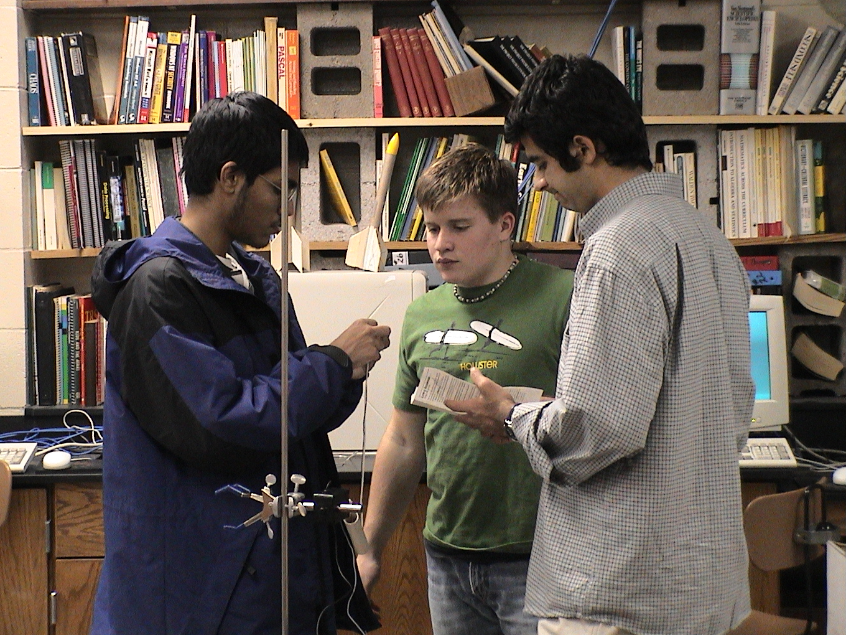

Metropolitan Vo-Tech Center
8:30 AM to 12:30 PM
August 7, 2007

David A. Young
1001 West Stone Street
Fayetteville, Arkansas 72701
(479) 443-9061
dayoung7@gmail.com
http://fayar.net/east/teacher.web/Math/young/

