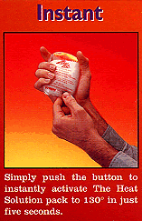

Abstract
As we do more and more data collection in the middle grades, we find that we have many opportunities to teach Experimental Design. That is, when we do the Scientific Process we start with an Observation that leads to a Hypothesis, which then fosters and Experiment that we must Design. Then we would conduct the Experiment and look at the Results that would then lead to additional experimentation, or other behaviors. Critical to the process is the Observation of phenomena, and then as we design the Experiment, looking at variables, which will either be measured or controlled. As we progress in the curriculum we then analyze the data created by the experiment, which is a natural connection to mathematics.

Introduction
This investigation will focus on Hot Pockets, the little packets that you “start” and then place in your pocket to keep you warm. We have two types to test, one is reusable and the other is disposable. References on these may be found at the following locations:
- How Stuff Works: http://www.howstuffworks.com/question290.htm
- Zap Pacs: http://www.heatandcomfort.com/zappac304.html
- Questions about sodium acetate crystallization: http://www.madsci.org/posts/archives/aug99/935202149.Ch.r.html
- Heat Factory Disposable Warmers!: http://www.heatfactory.com/warm.htm

Background
From the Environmental; Science Institute:
The Seven Key Concepts of Experimental Design
1. The Research Question: This is the question you want to answer. It is very important that it is clear and specific. This question often takes the form: "What effect does changing the IV (independent variable) have on the DV (dependent variable)." The research question should mention the independent and dependent variable(s).
2. Hypothesis: A guess at the answer to the question in the problem statement. It usually takes this form: If the IV (increases, decreases or remains the same) the DV will (increase, decrease, remain the same).
3. Independent (or Explanatory) variable(s) (IV): The variable that is purposely changed by the experimenter.
4. Dependent (or Responsive) variable(s) (DV): The variable that responds to changes in the independent variable.
5. Constant(s): All factors that are kept the same during the experiment.
6. Control group: Used as a standard of comparison for experimental effects. It receives no treatment and is used to tell if other treated samples have changed.
7. Repeated trials: The number of objects/organisms undergoing treatment for each value of the independent variable, or the number of times the experiment is repeated.

Procedure
- In the first step, we need to act on our observations, or experiences of these devices. Discuss with your partners and share with the class any experience you have had with this technology.
- List all the variables that you can think of in the situation/experiment. Mark the one that will be the Independent (Explanatory) and any others (preferably one) that will be the Dependent (Responsive).

Variables | Independent  or Dependent

- Now we need to state a Hypothesis that we would like to test. Discuss the ideas you have with your partner and then, as a team, write a sentence that reflects the hypothesis.
_________________________________________________________________
__________________________________________________________________
- Now we would like to design an experiment to test this hypothesis. We have two temperature probes and a CBL2 that will aid us in the experiment. Write a briefe description of the experiment, make a sketch of the set up, identify the length of the experiment and the rate at which data will be collected.
Describe it:________________________________________________________
__________________________________________________________________
Sketch:
Time of Experiment: ________________ Rate of data collection: ___________
- Run the DATAMATE program and SETUP the probes as well as the MODE for the experiment. If you don’t have the program in your calculator, TRANSFER if from the CBL2.
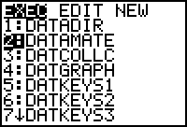 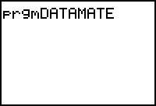
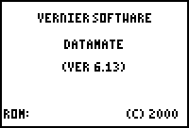 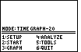
- Before the experiment happens, make a sketch of what you think the graph will look like, if the x-axis is time in seconds, and the y- axis is temperature in Celsius.

- How did the experiment turn out? What would you say about the support of your hypothesis? How would you change the experiment to get better results?

