As we do the Modeling of Physics as described by the ASU people [http://modeling.asu.edu/] it seems that the Transformation Graphing APP from TI [http://education.ti.com/us/product/apps/transgraph.html] to help as shown below.
Set up the generic quadratic showing displacement as a function of time in Y1. Then turn off that function and place on Y2 the first derivative of the function to get the velocity vs. time plot. Then as you adjust the values of A (acceleration), B (initial velocity), and C (initial displacement) the linear function for velocity is shown. The slope of the line will be acceleration and the y-intercept is the initial velocity. What is the x-intercept?

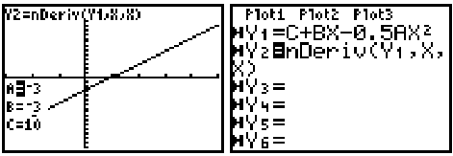

This can also be done to show the acceleration as a function of time plot as seen in Y3. Here the y-intercept is the initial acceleration and the slope is the jerk (rate of change of the acceleration).

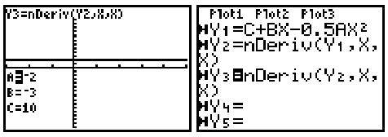
See the possible initial settings for the parameters:
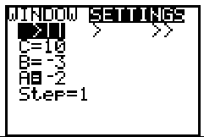

So if I give you the plot of Y1, Y2, or Y3 with the values of A, B and C, you should be able to sketch the missing graphs below [D vs. T, V vs. T, and A vs. T].

