Activity Overview
The Go Green club at your school is promoting composting. You have decided to participate, but in order for you to incorporate composting at your own house in the city, the compost bin will have to meet your neighborhood covenant restrictions. Design and construct a working compost bin that is odorless, cost-efficient, and portable.

Consider the following when creating your design.
- Build the bin with materials that you can gather at no cost
- Build your bin so that you can both turn the compost and access the compost to take appropriate measurements
- Mass Output : Mass Input and Volume Output : Volume Input ratios should be as close to 1 as possible.
- Your team will need to present your results in an Nspire Document. This presentation should not only document your work on the composter but support your compost as being a working compost bin that is odorless, cost-efficient, and portable.
Manage your composter at least once a week.
- Add to your compost by bringing food scraps from your house (or find a way to gather them from the cafeteria)
- Supplement your compost by bringing other items such as the following: grass clippings, leaves, and other appropriate ingredients
- Take measurements determined upon by your class to document the effectiveness of your compost
- Reminder: Back up your Nspire Document often
Materials
- TI-Nspire™ handheld technology or TI-Nspire™ CAS handheld technology
- TI-Nspire™ computer software (optional)
- Temperature Probes, pH Sensors, Soil Moisture Sensors, Ammonium Ion-Selective Electrodes*, Nitrate Ion-Selective Electrodes*, O₂ Gas Sensors, CO₂ Gas Sensors (computer only), Force Plate Sensors, Dual Range Force and the EasyLink
- Materials for constructing the compost bin
- Ingredients for feeding the compost
- Nspire Link with Direct Connect cable, or Unit-to-Unit cables to backup and share Documents
- Any safety equipment including safety glasses, gloves, and apron

Some Nspire skills you will need
Document Management: open, close, and save Documents; add new pages and problems | Look under Basics @ http://movies.atomiclearning.com/k12/ti_nspire/
Launch the Data Collection App, dismiss it, and adjust settings from the menu | http://movies.atomiclearning.com/movie/k12/27964/play
Load data (numerical and categorical) into List & Spreadsheet (L&S); use formulas and regression | http://movies.atomiclearning.com/movie/k12/40763/play  http://movies.atomiclearning.com/movie/k12/27959/play
Use various tools in Data & Statistics (D&S) including Categorical plots | http://movies.atomiclearning.com/movie/k12/40762/play
Sending and Receiving files with your handheld | http://movies.atomiclearning.com/movie/k12/27953/play

Part 1 – The Problem
In this part you want to come to understand the problem. Discuss in class the need for a solution. Consider who you need on your team. That is, what skills are needed and who has these skills?

Part 2 - The Engineering Design Process (EDP)

If you are not already familiar with the Engineering Design Process, then your teacher will lead you through an activity to become familiar with it. Think through The Composter as it relates to the Engineering Design Process. What will you do in each step?

Part 3 – Scoring Rubric

- Be sure to check the Rubric as you work on your design, implement it, test it, and present the results.

The Composter Rubric | 4  Expert | 3  Competent | 2  Beginner | 1  Novice
Evidence of research | Evidence of appropriate design of and materials for compost bin, knowledge of appropriate ingredients for compost, all references are credible | Some evidence of appropriate design of and materials for compost bin, knowledge of appropriate ingredients for compost, most references are credible | Little evidence of appropriate design of and materials for compost bin, knowledge of appropriate ingredients for compost, has at least one credible reference | Shows no evidence of research
Evidence of following the engineering design process (EDP) | Documents all steps of the EDP, including evidence of multiple design considerations | Documents most steps of the EDP, including evidence of more than one design consideration | Documents some steps of the EDP | Shows no evidence of following the EDP
Data collection with probeware | Uses multiple probes, has evidence of data, relevant data collection | Uses multiple probes, relevant data collection | Uses at least one probe | Shows no evidence of data collection
Effective use of the Nspire as a research notebook | Uses multiple Apps throughout the Document, labels all figures, uses appropriate units on all measures | Uses multiple Apps throughout the Document, labels most figures, uses appropriate units on most measures | Uses more than one App throughout the Document, use some labels and /or some appropriate units on measures | Shows no evidence of use of the Nspire
The Compost Bin | The bin allows access for accurate measurements, the bin allows adequate room for turning the compost, the bin is portable, materials for the bin were $0.00 | The bin allows access for accurate measurements, the bin allows adequate room for turning the compost, the bin is portable, materials for the bin cost between $0.01 and $5.00, inclusive | The bin allows access for measurements, the bin does not allow adequate room for turning the compost, the bin is not portable, materials for the bin cost more than $5.00 | The bin does not allow access for accurate measurements, the bin does not allow adequate room for turning the compost, the bin is not portable, materials for the bin cost more than $5.00
The Compost | There is evidence that the compost is working, is odorless, and that the ratio of Output volume : Input volume is high* | There is evidence that the compost is working and is relatively odorless | There is evidence that the compost is working | There is no compost
Effective presentation of the solution to your house through the use of the Nspire | Presents solution that outlines use of the EDP, answers relevant questions in an expert manner | Presents solution that outlines use of the EDP, answers relevant questions in an acceptable manner | Presents solution, answers most relevant questions acceptably | Presents solution, answers relevant questions unsatisfactorily
Evidence of team work with individual responsibility | Evidence that the design was chosen as a team through thoughtful deliberation, all team members are able to explain to the class what they did in the activity | Evidence that the design was chosen as a team after some deliberation, most team members are able to explain to the class what they did in the activity | Evidence that the design was chosen as a team after a little discussion, some team members are able to explain to the class what they did in the activity | Evidence that the design was chosen as a team hastily with out much discussion, only one team member is able to explain to the class what he did in the activity
*High to be determined by the teacher or the class.

Part 4 – Design the Composter

- What kinds of materials work best in compost? Are there any materials you should avoid?
- For what kind of garden are you creating compost? Are there any must-have ingredients for this type of compost? Are there any ingredients to avoid?
- Consider safety issues related to materials, chemicals, and the construction process throughout the design plan.
- Your design should be researched based. Report references as you plan and present using the Notes App on the Nspire.
- Pay attention to the Rubric as you create your design.
- Be realistic as your team designs the Composter. Your team will need to build and use it.
- Once you have created your design, have it approved by your instructor.
- Document your work in the Nspire and back up the file often.
Part 5 – Build the Composter

- Keep in mind that your goal is to build the Composter at no cost.
- Is your Composter portable?
- Pay attention to safety as you build your Composter. Use tools correctly, use appropriate safety devices, and get assistance from your instructor if necessary.
- Make notes of your progress each day in an Nspire Document.
Part 6 – Use the Composter

- How will you obtain the ingredients necessary for your compost?
- Can you design a process for collecting appropriate food scraps from your school cafeteria?
- For what are you going to use the compost? What type of pH level should your compost have for that use?
- It will take a bit of time for the Composter start working, but you will need to collect baseline data at the start.
- Make notes of your progress each day in an Nspire Document.

Part 7 – Test the Model
Throughout the project, and at least weekly, use probes to collect readings on various aspects of your compost. Store the data in a spreadsheet, and analyze the data at the conclusion of the project.
- If you are reading the temperature of the compost, consider from how many different locations in the pile you should collect data.
- If you are measuring the pH level of your compost, consider whether you need to add any ingredients in order to change the pH level?
- Use other sensors with your Nspire as directed by your teacher.
Select a probe to test your compost. For example, if you want to test temperature and you do not have EasyTemp, you will need an EasyLink to connect your temperature probe to the Nspire. Plug the probe in and the Data Collection App should launch. If the Data Collection App does not automatically launch use /D to launch it. Decide where you want the data displayed. You can see what probes are available for the Nspire at: Data Collection with TI-Nspire™ [http://www.vernier.com/calc/ti-nspire/data-collection.html].
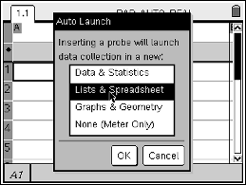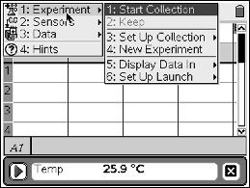

Adjust the settings for the probe from the Menu. Press b and explore. You might want to change the type of data collection, the length of the experiment or the units. You can even zero the probe if you wish. You can also Set Up Collection for Selected Events or Events with Entry.
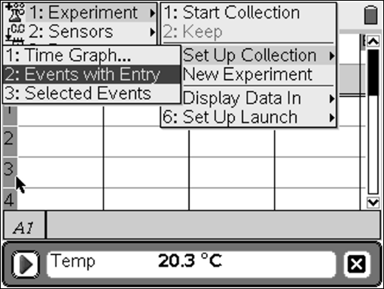

To start data collection e over to the Play button and press ·. You will notice that the Play button becomes a Stop button during data collection. If you set up collection for selected events, you will notice a filing cabinet icon to click to record each time you want to save a reading. Click on the icon each time you want to collect a reading. You can press · to stop when you wish. To explore the data you can get your focus off of the data collection by using /e.
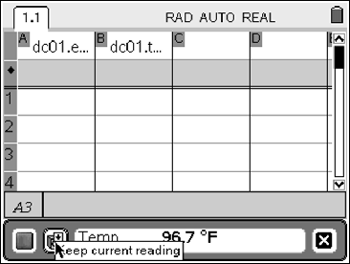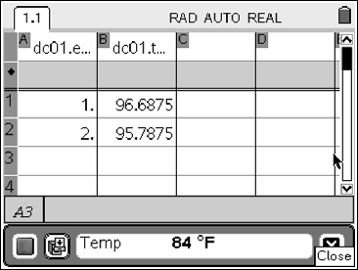
You can dismiss the Data Collection App by switching back your focus and then tabbing to the X.

You will probably want to take the temperature in several different locations in your compost pile. When your focus is on the Data Collection APP, you can save your data before a new collection by pressing Menu > Data > Store Run. Take the mean or maximum or whatever statistic is most appropriate of your temperature list and record it for your analysis.

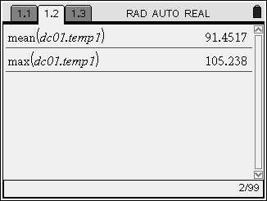

Using other probes to collect additional data for your compost pile works similarly.

Your team needs to keep records of data that you collect over time. Do this in a List & Spreadsheet Page of an Nspire Document. Add a new Page to your Document by pressing c and selecting the Lists & Spreadsheet option. Move to the top of each column and give it a name. Move down to the first cell and then place the date in quotes so the Nspire will treat it as a word and not a number.
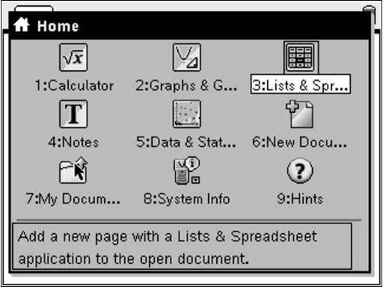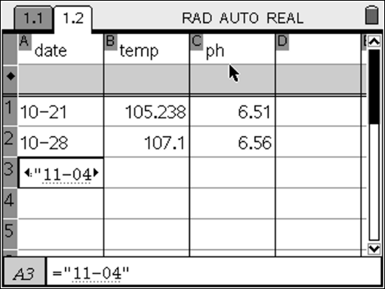

Part 8 – Present the Solution
- Analyze the data that you have collected. One way to do this is in a Data & Statistics Page of an Nspire Document. Add a new Page to your Document by pressing c and selecting the Data & Statistics option. Click on the bottom center of the screen to choose the independent variable (data), and then click on the left center of the screen to choose the dependent variable (temp).
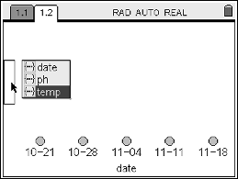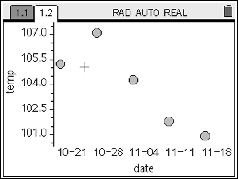
What basic shape is the data? What is happening to the data over time? Can you use your data to predict what will happen to the compost next week? In a month?
- Organize your Nspire Document so that you can present your composting process to your classmates.

Your presentation will be done through an Nspire Document. You can use the Pages that you collected above. One way to do this would be to copy the pages and add them to a new Problem in the order that you want to present them. To copy a Page, while you are on that Page press /K to capture the page (notice how excited the Page gets) and then either copy or cut it with a /C or /X. Then move to where you want to paste the page and select /V. You can see all of your Pages and Problems by moving up with /` but you will need to have a full view of a Page to paste.
- Look at the Rubric before you finalize your presentation and present your model for testing.
- You might want to practice the presentation with the Teacher Edition of the software or the Nspire Panel.
- Send the final Document to each team member and the teacher.

Extensions
- Use the compost you have created in appropriate places on the school grounds or in other locations. Are there already established gardens that need compost? Is it possible to plan a new garden using the compost? Which comes first: the Composter or the garden that needs the compost?
- Determine the best place on the school grounds for a composter based on the results from the teams’ Composter designs. Would one design work better in one location while another design would thrive in another location?
- Take your Composter home so that you can continue the process of composting.
- Make a webpage or brochure to share what you have learned about composting and make a plan to publicize and distribute this information. Contact the school or local paper, start a Composter Blog, etc. Use this as a Community Service project.

