Ball Bounce III

Algebraic Connections

Date_______ Period_______
Team Members (Indicate yourself!):

_________________ _________________

_________________ _________________

We now wish to explore the Bouncing Ball for one last (?) time in our quest for the Quadratic within. If “we” didn’t collect the information, then we could collect information about time as well as height from the bouncing ball. Maybe that would be where we could find the Quadratic? So, here we go with one more try!
Materials
- Racquet Ball | - Tape for the wall | - CBR
- 150 Centimeter  Tape measure  - Digital Camera | - TI-83 Plus/  TI-83/TI-82  graphing calculator with 8000 bytes free | - TI-Interactive!  Excel or  Graphical Analysis (Optional)
- Pen or Pencil | - Instructions | - RANGER program
- Long CBR to TI-83/82 Cable | - Clamp for the CBR | - TI Graph Link

- In your group, collect the data for a dropped ball when it is dropped from a height of just above 100 centimeters. Pick a location from which you can attach the CBR clamp so that the “eye” of the range finder is 150 cm above the floor. The goal is to use the RANGER program, using the Ball Bounce application to get data for about 5 or 6 bounces, with the times that are associated with the bouncing ball. Drop the ball so it moves straight up and down as it bounces.
- Set up the experiment and test it out with the RANGER program.
- To get the RANGER program into your calculator, make sure you have enough free space (press  [MEM] and see if you have at least 8000 bytes free). If needed, go to the Graph Link and save your files so that you may then delete them, or just delete them. If you have a TI-83 Plus you may ARCHIVE files to free up working memory. This program uses list L1 through L6, so they will be erased as you do the experiment. Connect the CBR to the calculator and prepare the calculator to receive. If the screen shows Waiting…. Then press the 82/83 button on the CBR to send the RANGER program. TI-83 Plus people may use the CBL/CBR APP, and select RANGER from that menu.
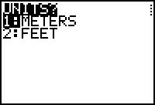
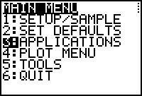
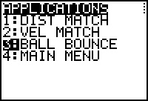
- Run the RANGER program and select 3:APPLICATIONS from the MAIN MENU. Then select 1:METERS from the UNITS? Menu and 3:BALL BOUNCE from the APPLICATIONS Menu.
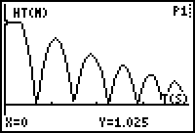
- Follow the instructions and drop the ball, just after your partner presses the TRIGGER on the CBR. The ball should be held under the CBR at just above 100 cm from the floor, so that the CBR will pick up the bounces from 100 cm down. If you get a graph like this, then you have your data! It will take several trials to get data like this.
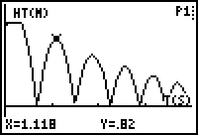
- Trace on this data to make sure you have at least 100 cm as the first bounce. In this case we have 82 cm.
- Take a Digital photograph showing your experimental set up and the positioning of the ball as it is dropped.
- Trace along the graph and identify the X (time in seconds) and Y (height in meters) of each peak of the graph. This represents the height of each bounce. Call the 1st good peak Bounce 1. Fill in the data in TABLE 1. Collect as many peaks as you are sure of.
Table I
Bounce  Number | Time  (seconds) | Height  (cm)
1
2
3
4
5
6
7

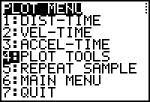
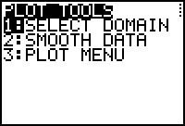
- Now select off one bounce to see the Quadratic. From the PLOT MENU pick option 4:PLOT TOOLS and the 1:SELECT DOMAIN from the PLOT TOOLS menu.
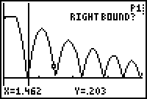
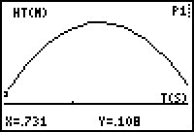
- Move the cursor to select the Left and Right bounds of one complete bounce. Make sure you collect only data for that bounce and not grab data from the bounce before and the one after. If you are successful, your graph should look like mine.
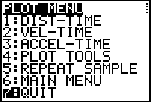
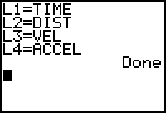
- Leave the program and share the lists (L1 and L2) with your team members. Make sure everyone has the data before you leave class, and someone should place it on the computer for safe keeping. If you screw up the data, you might be able to pull it off of the CBR again, before the next class uses it.
- Calculate the Ratios of the Heights from Table I and then report the Average Ratio.
Table II
Ratio of Bounce Heights

- Average of the Ratios: ___________________________
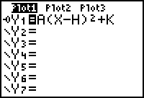
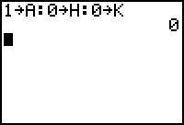
- Now we wish to get the name of the Quadratic that represents this bounce. Go to the □ editor and place in the other general form of the Quadratic. Let A, H, and K have their default values.
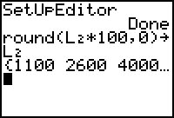
15. Before we test this choice out, let us change the values of the distance in L2 to centimeters. This will help us as we calculate, and guess BubbleBaby.
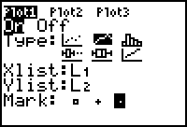
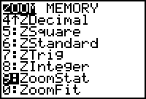
- Make sure your Plot is set up correctly and then  .
- Adjust the values of A, H, and K until you have the best fit. Turn in your work from the calculator, with the photo and the lists with this sheet.

