To stop a program or function manually,

 | - | Windows®: Hold down the F12 key and press Enter repeatedly.

 | - | Mac®: Hold down the F5 key and press Enter repeatedly.

 | - | Handheld: Hold down the c key and press · repeatedly.

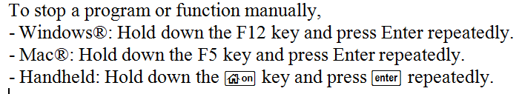

Break a Prgm

To 'break' a program on TI-Nspire:
Handheld: hold [on] and repeatedly press [enter]
Windows: hold F12 (sometimes Fn-F12) and repeatedly press enter.
Mac: hold F5 and repeatedly press enter
iPad: ?

