CAS in Algebra

“Everything they learn to do with CAS they should be able to do without CAS.”

March 4, 2005
Stevenson High School

Paul Sally
New Trier High School
sallyp@newtrier.k12.il.us
Algebra I Lesson – Math tricks and simplifying expressions

1) Follow these steps:

Description | With a number | With another number
Pick a number
Add 5
Multiply by 2
Add 4
Divide by 2
Subtract 7

2) Let’s do the trick on the TI-92

Description | With Algebra | With CAS
Pick a number
Add 5
Multiply by 2
Add 4
Divide by 2
Subtract 7

3) Makeup your own trick…

Description | With a number | With Algebra | With CAS
Pick a number
Add ______
Multiply by 2
Add ______
Divide by 2
Subtract ______

4) The Trick to The Trick

Description | With CAS
Pick a number
Add ______
Multiply by 2
Add ______
Divide by 2
Subtract ______

5) Another Trick. Follow these steps…
Description | With a number | With another number
Pick a number
Add 6
Multiply by 4
Add 2
Divide by 2
Add 5
Divide by 2
Subtract your number

6) Let’s do the trick on TI-92
Description | With Algebra | With CAS
Pick a number
Add 6
Multiply by 4
Add 2
Divide by 2
Add 5
Divide by 2
Subtract your number

7) Makeup your own trick…
Description | With a number | With Algebra | With CAS
Pick a number
Add ______
Multiply by 4
Add ______
Divide by 2
Add _______
Divide by 2
Subtract your number

8) The Trick to The Trick
Description | With CAS
Pick a number
Add ______
Multiply by 4
Add ______
Divide by 2
Add _______
Divide by 2
Subtract your number

Evaluating Expressions/Order of Operations

1) The “|” key
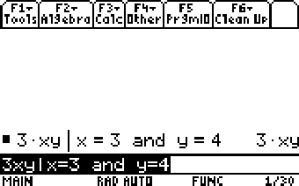
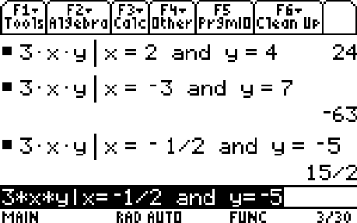
2) Predict/Check/Reflect

Predict | Check | Reflect
Evaluate x² –8x with x = 5

Evaluate xy – x – y with x = -2 and y = -5

Evaluate x² with x = -7

3) Evaluate y = 3x + 2 with x = 2 and y = 8

4) Evaluate y = 3x + 2 with x = -1 and y = -5

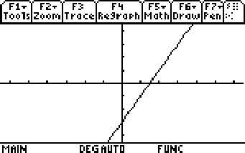
5) Evaluate the equation y = 2x – 3 for each point below. If the point evaluates to false put an X at that location. If the point evaluates to true put a at that location.

a) (2, 4) b) (3, 3) c) (-1,3)

d) (3, -2) e) (2, 1) f) (0, -3)

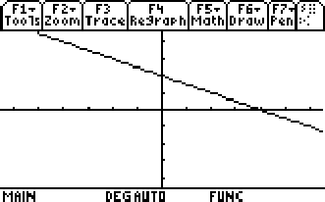
6) Evaluate the equation y = -½x + 2 for each point below. First, predict whether each point will evaluate to true or false. Then use your calculator to see if your predictions are correct. Remember if the point evaluates to false put an X at that location. If the point evaluates to true put a at that location.

a) (2, 4) b) (4, 0) c) (0, 0)

d) (-2, 3) e) (6, -1) f) (20, -8)

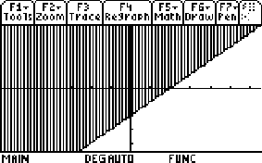
7) Evaluate y for the following points. If the point evaluates to true put a at that location.

a) (0,0) b) (4,0) c) (1,3)

d) (-2, 5) e) (4, 2) f) (-2, -4)

Solving Linear Equations

1) For the screen shot below:

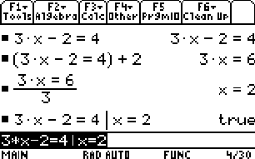
a) What was the original problem?

b) What were the two transformations used to solve the equation?

c) What is the solution?

d) Was the answer checked?

2) Below are two attempts by students to solve the problem 3 – 4t=11. How could the screen shot be used to help these students correct their mistakes?
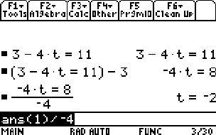
Student 1 Student 2
3 – 4t = 11 3 – 4t = 11
-3 -3 +3 +3
4t = 8 -4t=14
4 -4
t = 2 t=-3.5

3) Predict/Check/Reflect

Predict | Check | Reflect
3x + 7 = -2x + 5

4) Solve for y: 3x + y = 12

A Few Things To Watch Out For or Great Examples For Math Discussions

- ½x

- 3(x + 2)

- 3(x+2) – 5

- Solve 3(x +2) = 12

- 3(y – x)

- Solve for y: 3x + 4y = 12

Functions

- Define f(x) = 3x – 2
  - Calculate f(3)
  - Find x when f(x) = 10
  - Find f(2t)

- Define a(b,h) = ½bh and find a(8, 3)

- Define g(x) = x² + 5
  - Find f(g(x))
  - Finf g(f(x))

- Consider p(x) = 2x³ – 7 as the composition of three functions.
  - Define those three functions and write p(x) as a composition of those three functions.

  - Can a composition of these same functions be used to create q(x) = 8x³ – 7

