Activity 1: Discovering Mathematics with the TI-73 (activity 11)
Exploring Probability with M&M’s®
- Create a list on the TI-73 Explorer named COLOR
  - Press .
  - Move the cursor to the header of the 1st list by using the  keys and then press  until all named lists are gone.
  - To name the list COLOR, while the cursor is in the header of the first column press  and use the arrow keys to spell Color, pressing  after each letter.
  - When finished select Done and press 
  - Press  again and the list will be named.
- Press the  to get COLOR (1)=
- Enter the colors of the M&M’s® into the list
  - To make this a categorical list enclose the first element in quotation marks when you enter it (example: “BROWN”)
  - Press  and use the arrow keys to spell BROWN pressing  after each letter
  - Press the  to move to Done and press 
- Press  again and BROWN will be pasted on the calculate screen under the list named COLOR.
- Continue this process until you have entered all the colors. [six letter word limit]
- Now you are ready to enter the data
- Using the arrow keys move to the top of the next column for a new list to be named DATA. Use the text editor just as before. When finished, press the  key to get to the first element in the DATA list. [the number of brown M’s]
- Enter the number of each color in this list, pressing  after each number.

Activity 2: Creating a Circle Graph (Continuation of activity one)
- Press  to get the STAT PLOTS screen.
- Select Plot 1 with your cursor and press 
- Press  to highlight On. This turns the plot on.
- Press  to move to the circle graph and press  to select it.
- For CategList, choose the COLOR list. Press and use the arrow to move down to color and press 
- Do the same for Datalist but this time select the list named DATA.

Before graphing you must turn plots on or off.
Press  and move up to the Plot names and press  to turn plots on or off. [Dark is ON]
Press  to see the circle graph
Press  use the arrow keys to explore your circle graph

Activity 3: Fractions, Decimals and Percents
- To enter a fraction in stacked format, enter the numerator then press  then type in the denominator.
- To add another fraction to what you have entered press  and select .
- Following the steps in step 1, type in the second fraction and then press .
4. If you have a mixed number, type in the whole number and then press 
- Type in the fraction part using the  key.
- Change the fraction from an improper fraction to a mixed number or mixed number to improper fraction using the  
- Change the fraction to a decimal using the  
- If the number is a percent pressing  will convert it into a decimal.
- Simplify a fraction by pressing  

Activity 4: Preparing for a Party (extension of activity 3)
- Use the recipe below. Tell your students that they are in charge of making 100 cookies for the school party.
- Using your TI-73 Explorer™ and knowledge about fractions make the changes to the recipe so that you have enough dough to make 100 cookies.

Peanut Butter Chocolate Chunk Cookies
Recipe makes 2 dozen Recipe makes 100 cookies
Ingredients: Ingredients:
1 cup butter ______________________
1 cup peanut butter ______________________
2/3 cup white sugar ______________________
2/3 cup brown sugar ______________________
2 eggs ______________________
1 teaspoon salt ______________________
1 teaspoon vanilla ______________________
1 teaspoon baking soda ______________________
2 cups flour ______________________
12 ounce package of chocolate chips ______________________

Activity 5: Discovering Mathematics with the TI-73 (Activity 2)
Finding the Greatest Common Factor
Prework: Write some fractions on the board or use examples from a textbook.
Example: 18
24
- Press , use the arrow keys to move down and over to  press 
- Now move the cursor to Mansimp (manually simplify) and press 
- Press  to return to the Home Screen.
- Have students enter the fractions you have given them.
  - Type the numerator and press , type the denominator and press 
- Ask the students to figure out if the fraction is simplified. If not, what number could you divide into both parts to get a simplified answer?
- Press  . The calculator displays the new fraction and the lowest prime factor of the numerator and denominator
- Continue the   process until the fraction is in lowest terms
- Remind students of the definition of GCF.
- To reinforce this concept have the students type in the fraction they started with then  then type the GCF answer and .

Activity 8: Converting Units of Measure
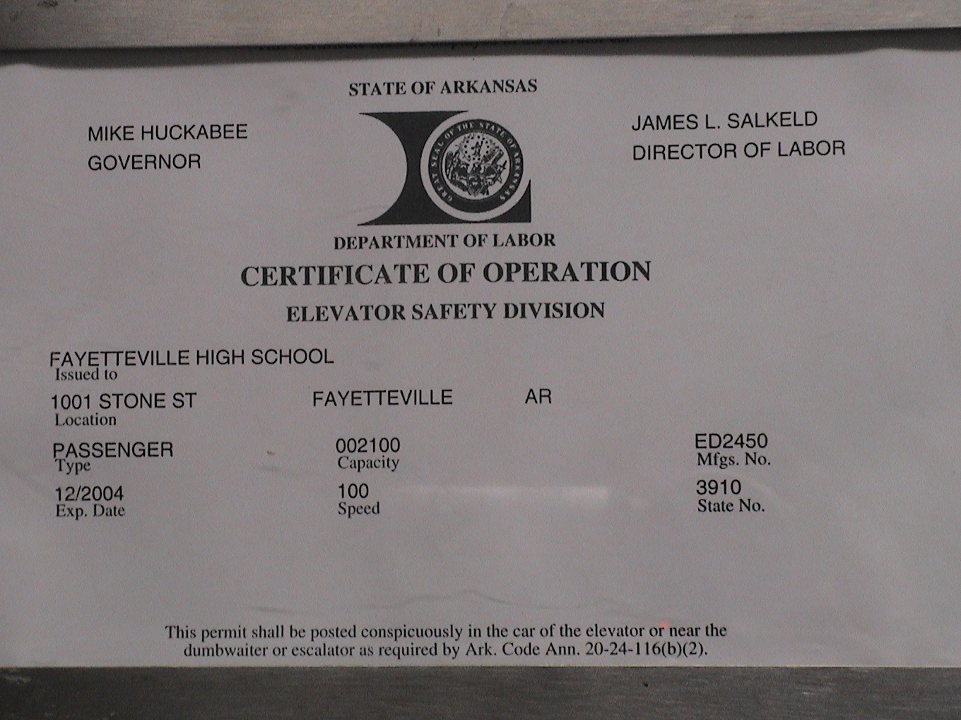
- Enter 100 on your Home Screen since the speed of this elevator is 100.
- Press   (to access the CONVERT feature)
- Select 7: Speed
- Using the arrow keys scroll down to some starting unit like 3: mi/hr press .
- Using the up arrow key press  on a second unit like 2: m/s to convert to.
- Press  to see the answer
- Repeat this several times using different units until you think you know the units of the speed of the elevator.
- Write an explanation for your unit selection.
Activity 10: Who Won?
Have your students put the following information into a list. Convert the information into a bar chart to see what 2000 Olympic team took home the most medals.
Olympic Statistics came from: http://www.darmoni.net/

- Refer to Activity 1 for directions on how to enter data into a list.
Country (Coun) | Gold | Silver (Silve) | Bronze (Bronz)
Australia (Aus) | 16 | 25 | 17
China | 28 | 16 | 15
Germany (Ger) | 14 | 17 | 25
Russia (Rus) | 32 | 27 | 17
United States (USA) | 39 | 25 | 32

Creating a Bar Graph
- Press 
- Select Plot 1 and press 
- Press  to highlight On
- Press   to move to the bar graph and press  to select it
- For CategList, choose COUN. To get this list press and use the arrow to move down to word and press 
- Do the same for Datalist but this time press GOLD for list 1, SILVE for list 2 and BRONZ for list three.
- Press  to select Vert and using the arrow keys highlight 3 and press 

Before graphing you must turn plots on or off.
Press  and move up to the Plot names and press  to turn plots on or off. [Dark is ON]
Press  to see the bar graph
Press  use the arrow keys to find who earned the most medals

To delete previous lists, press •.
To delete text from the list press .

Activity 11: Exploring Area
- Turn on your TI-73 Explorer and press .
- Scroll down to find AreaForm and press 
- Press any key to go through the beginning screens.
- On the Select a Mode screen press  on number 1: Definitions and Formulas
- Use this tutorial to define and learn the formulas of each shape

Example: To find a shapes formula:
  - From the Definition page
  - Press  (the soft key under Area)

To see an example of finding the area:
- Press  (the soft key under Example)

To get back to a previous screen press  or the  (the soft key for Menu)

Activity 12: Area Quiz
It’s your turn to find the area of a shape on your own!
1. Turn on your TI-73 Explorer and press .
2. Scroll down to find AreaForm and press 
3. Press any key to go through the beginning screens.
4. On the Select a Mode screen press  on number 2: Area Quiz
5. Select your level by using the  and press  
- Use pencil and paper to figure out the correct answer and use  to select A, B, C or D.

Activity 13: Probability Simplified
1. Turn on your TI-73 Explorer and press .
2. Scroll down to find Prob Sim and press 
3. Press any key to go through the beginning screen.
4. Use the arrow keys to scroll down to Spin Spinner and press 
5. Press  to spin the spinner once.
6. Press  to spin the spinner 10 times
7. To find out how many times the spinner landed on 3 in the 11 spins press  
8. Look at your graph and count up the number of times you landed on the number 3.
9. What is the probability you will land on 4?

