Geometry

Mathematics
Curriculum Framework

Revised 2004
Amended 2006

Course Title: Geometry
Course/Unit Credit: 1
Course Number:
Teacher Licensure: Secondary Mathematics

Grades: 9-12

Geometry

This course will help students develop communication skills, enhance reasoning, and make connections within mathematics to other disciplines and the real world. Students will use physical models and appropriate technology to investigate geometric concepts in problem solving situations. In this course, students are engaged in problematic situations in which they form conjectures, determine the validity of these conjectures, and defend their conclusions to classmates.

Strand Standard
Language of Geometry
1. Students will develop the language of geometry including specialized vocabulary, reasoning, and application of
theorems, properties, and postulates.
Triangles
2. Students will identify and describe types of triangles and their special segments. They will use logic to apply the
properties of congruence, similarity, and inequalities. The students will apply the Pythagorean Theorem and
trigonometric ratios to solve problems in real world situations.
Measurement
3. Students will measure and compare, while using appropriate formulas, tools, and technology to solve problems
dealing with length, perimeter, area and volume.
Relationships between two- and three- dimensions
4. Students will analyze characteristics and properties of two- and three-dimensional geometric shapes and develop
mathematical arguments about geometric relationships.
Coordinate Geometry and Transformations
5. Students will specify locations, apply transformations and describe relationships using coordinate geometry.

* denotes amended changes to the framework

Language of Geometry

Content Standard 1. Students will develop the language of geometry including specialized vocabulary, reasoning, and application

of theorems, properties, and postulates.

LG.1.G.1 | Define, compare and contrast inductive reasoning and deductive reasoning for making predictions based on real world situations  - venn diagrams  - matrix logic  - conditional statements (statement, inverse, converse, and contrapositive)  - *figural patterns
LG.1.G.2 | Represent points, lines, and planes pictorially with proper identification, as well as basic concepts derived from these undefined terms, such as segments, rays, and angles
LG.1.G.3 | Describe relationships derived from geometric figures or figural patterns
LG.1.G.4 | Apply, with and without appropriate technology, definitions, theorems, properties, and postulates related to such topics as complementary, supplementary, vertical angles, linear pairs, and angles formed by perpendicular lines
LG.1.G.5 | Explore, with and without appropriate technology, the relationship between angles formed by two lines cut by a transversal to justify when lines are parallel
LG.1.G.6 | Give justification for conclusions reached by deductive reasoning  *State and prove key basic theorems in geometry (i.e., the Pythagorean theorem, the sum of the measures of the angles of a triangle is 180° , and the line joining the midpoints of two sides of a triangle is parallel to the third side and half it’s length

Triangles

Content Standard 2. Students will identify and describe types of triangles and their special segments. They will use logic to apply the
properties of congruence, similarity, and inequalities. The students will apply the Pythagorean Theorem and
trigonometric ratios to solve problems in real world situations.

T.2.G.1 | Apply congruence (SSS …) and similarity (AA ...) correspondences and properties of figures to find missing parts of geometric figures and provide logical justification
T.2.G.2 | Investigate the measures of segments to determine the existence of triangles (triangle inequality theorem)
T.2.G.3 | Identify and use the special segments of triangles (altitude, median, angle bisector, perpendicular bisector, and midsegment) to solve problems
T.2.G.4 | Apply the Pythagorean Theorem and its converse in solving practical problems
T.2.G.5 | Use the special right triangle relationships (30˚-60˚-90˚ and 45˚-45˚-90˚) to solve problems
T.2.G.6 | Use trigonometric ratios (sine, cosine, tangent) to determine lengths of sides and measures of angles in right triangles including angles of elevation and angles of depression
T.2.G.7 | *Use similarity of right triangles to express the sine, cosine, and tangent of an angle in a right triangle as a ratio of given lengths of sides

Measurement

Content Standard 3. Students will measure and compare, while using appropriate formulas, tools, and technology to solve problems
dealing with length, perimeter, area and volume.

M.3.G.1 | Calculate probabilities arising in geometric contexts (Ex. Find the probability of hitting a particular ring on a dartboard.)
M.3.G.2 | Apply, using appropriate units, appropriate formulas (area, perimeter, surface area, volume) to solve application problems involving polygons, prisms, pyramids, cones, cylinders, spheres as well as composite figures, expressing solutions in both exact and approximate forms
M.3.G.3 | Relate changes in the measurement of one attribute of an object to changes in other attributes (Ex. How does changing the radius or height of a cylinder affect its surface area or volume?)
M.3.G.4 | Use (given similar geometric objects) proportional reasoning to solve practical problems (including scale drawings)
M.3.G.5 | *Identify and apply properties of and theorems about parallel and perpendicular lines to prove other theorems and perform basic Euclidean constructions

Relationships between two- and three- dimensions

Content Standard 4. Students will analyze characteristics and properties of two- and three-dimensional geometric shapes and develop

mathematical arguments about geometric relationships.

R.4.G.1 | Explore and verify the properties of quadrilaterals
R.4.G.2 | Solve problems using properties of polygons:  - sum of the measures of the interior angles of a polygon  - interior and exterior angle measure of a regular polygon or irregular polygon  - number of sides or angles of a polygon
R.4.G.3 | Identify and explain why figures tessellate
R.4.G.4 | Identify the attributes of the five Platonic Solids
R.4.G.5 | Investigate and use the properties of angles (central and inscribed) arcs, chords, tangents, and secants to solve problems involving circles
R.4.G.6 | Solve problems using inscribed and circumscribed figures
R.4.G.7 | Use orthographic drawings ( top, front, side) and isometric drawings (corner) to represent three-dimensional objects
R.4.G.8 | Draw, examine, and classify cross-sections of three-dimensional objects
R.4.G.9 | *Explore non-Euclidean geometries, such as spherical geometry and identify its unique properties which result from a change in the parallel postulate

Coordinate Geometry and Transformations

Content Standard 5. Students will specify locations, apply transformations and describe relationships using coordinate geometry.

CGT.5.G.1 | Use coordinate geometry to find the distance between two points, the midpoint of a segment, and the slopes of parallel, perpendicular, horizontal, and vertical lines
CGT.5.G.2 | *Write the equation of a line parallel to a line through a given point not on the line
CGT.5.G.3 | *Write the equation of a line perpendicular to a line through a given point
CGT.5.G.4 | *Write the equation of the perpendicular bisector of a line segment
CGT.5.G.5 | Determine, given a set of points, the type of figure based on its properties (parallelogram, isosceles triangle, trapezoid)
CGT.5.G.6 | Write, in standard form, the equation of a circle given a graph on a coordinate plane or the center and radius of a circle
CGT.5.G.7 | Draw and interpret the results of transformations and successive transformations on figures in the coordinate plane  - translations  - reflections  - rotations (90˚, 180˚, clockwise and counterclockwise about the origin)  - dilations (scale factor)

GEOMETRY Glossary

Adjacent angles | Two coplanar angles that share a vertex and a side but do not overlap
Alternate interior angles | Two angles that lie on opposite sides of a transversal between two lines that the transversal intersects  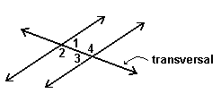
Altitude of a triangle | A perpendicular segment from a vertex of a triangle to the line that contains the opposite side
Angle | Two non-collinear rays having the same vertex
Angle of depression | When a point is viewed from a higher point, the angle that the person’s line of sight makes with the horizontal  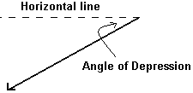
Angle of elevation | When a point is viewed from a lower point, the angle that the person’s line of sight makes with the horizontal  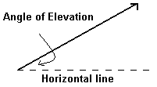

Apothem | The distance from the center of a regular polygon to a side  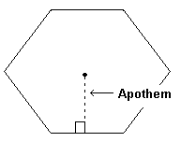
Arc | An unbroken part of a circle
Area | The number of square units needed to cover a two-dimensional space.
Attributes | A quality, property, or characteristic that describes an item or a person (Ex. color, size, etc.)
Biconditional | A statement that contains the words “if and only if” (This single statement is equivalent to writing both  “if p, then q” and its converse “if q then p.)”
Bisector | A segment, ray or line that divides into two congruent parts
Center of a circle | The point equal distance from all points on the circle
Central angle | An angle whose vertex is the center of a circle (Its measure is equal to the measure of its intercepted arc.)  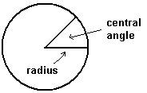

Centroid | The centroid of the triangle is the point of congruency of the medians of the triangle.  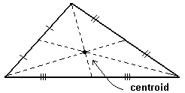
Chords | A segment whose endpoints lie on the circle
Circle | The set of all points in a plane that are an equal distance (radius) from a given point (the center) which is also in the  plane
Circumcenter | A circumcenter is the point of concurrency of the perpendicular bisectors of a triangle.  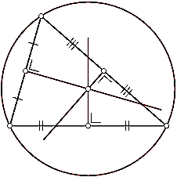
Circumference | The distance around a circle
Circumscribed | A circle is circumscribed about a polygon when each vertex of the polygon lies on the circle.  (The polygon is I inscribed in the circle.)  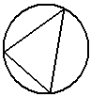
Collinear points | Points that lie on the same line
Complementary angles | Two angles whose measures add up to 90 degrees
Concentric circles | Concentric circles lie in the same plane and have the same center

Conditional statements | A statement that can be written in the form “if p, then q”  (Statement p is the hypothesis and statement q is the conclusion.)
Cone | A three dimensional figure with one circle base and a vertex  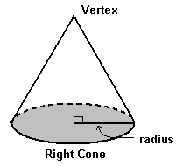
Congruent | Having the same measure for angles and segments. Having the same measure and shape for shapes
Conjecture | Something believed to be true but not yet proven (an educated guess)
Consecutive angles | In a polygon, two angles that share a side  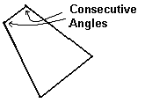
Consecutive sides | In a polygon, two sides that share a vertex
Contrapositive | The contrapositive of a conditional statement (“if p, then q” is the statement “if not q, then not p”)
Converse | The converse of the conditional statement interchanges the hypothesis and conclusion  (“if p, then q, becomes “if q, then p”)
Convex polygon | A polygon in which no segment that connects two vertices can be drawn outside the polygon
Coordinate geometry | Geometry based on the coordinate system

Coordinate plane | A grid formed by two axes that intersect at the origin (The axes divide the plane into 4 equal quadrants.)
Coplanar points | Points that lie in the same plane
Corollary | A corollary of a theorem is a statement that can easily be proven by using the theorem.
Corresponding parts | A side (or angle) of a polygon that is matched up with a side (or angle) of a congruent or similar polygon  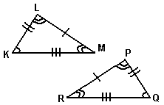
Cosine | In a right triangle, the ratio of the length of the leg adjacent to the angle to the length of the hypotenuse
Cross-section | A cross-section is the intersection of a solid and a plane.
Cylinder | A three-dimensional figure whose bases are circles of the same size  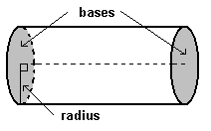
Deductive reasoning | Using facts, definitions, and accepted properties in a logical order to reach a conclusion or to show that a conjecture  is true
Dilations | Transformations producing similar but not necessarily congruent figures

Exterior angle of a polygon | An angle formed when one side of the polygon is extended  (The angle is adjacent to an interior angle of the polygon.)  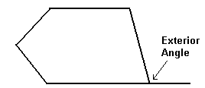
Geometric mean | If a, b, and x are positive numbers, and a/x = x/b, then x is the geometric mean of a and b.
Incenter | The incenter of a triangle is the point of congruency of the angle bisectors of the triangle.  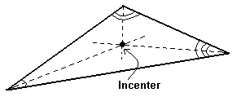
Inductive reasoning | A type of reasoning in which a prediction or conclusion is based on an observed pattern
Inscribed angle | An angle whose vertex is on a circle and whose sides are chords of the circle  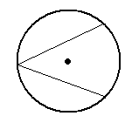

Inscribed circle | A circle is inscribed in a polygon if the sides of the polygon are tangent to the circle.  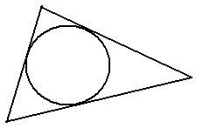
Inscribed polygon | A polygon is inscribed in a circle if the vertices of the polygon are on the circle.  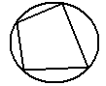
Interior angles of a polygon | The inside angle of a polygon formed by two adjacent sides
Inverse statement | The inverse of the conditional statement (“if p, then q” is the statement “if not p, then not q”)
Irregular polygon | A polygon with at least two non-congruent sides or angles
Isometric drawings | Drawings on isometric dot paper used to show 3-dimensional objects
Isosceles triangle | A triangle with at least two sides congruent
Line of symmetry | The line over which a figure is reflected resulting in a figure that coincides exactly with the original figure
Linear pair of angles | Two adjacent angles form a linear pair if their non-shared rays form a straight angle.  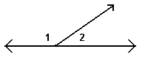
Matrix logic | Using a matrix to solve logic problems

Median of a triangle | A segment that has as its endpoints a vertex of the triangle and the midpoint of the opposite side  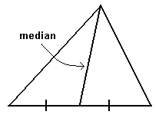
Midpoint of a segment | The point that divides a segment into two congruent segments
Midsegment | A segment whose endpoints are the midpoints of two sides of a polygon  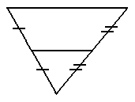
Orthocenter | The orthocenter is the point of concurrency of the altitudes of a triangle.  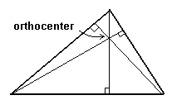
Orthographic drawings | An orthographic drawing is the top view, front view and right side view of a three-dimensional figure.
Parallel lines | Lines in a plane that do not intersect
Parallelogram | A quadrilateral with both pairs of opposite sides parallel

Perimeter | The distance around a polygon
Perpendicular bisector | The perpendicular bisector of a segment is a line, segment or ray that is perpendicular to the segment at its midpoint.  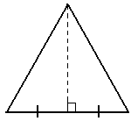
Perpendicular | Two lines, segments, rays, or planes that intersect to form right angles
Planes | A flat surface having no boundaries
Platonic solid | A polyhedron all of whose faces are congruent regular polygons, with the same number of faces meeting at every  vertex  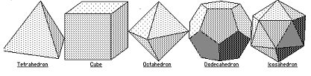
Point | A specific location in space
Polygon | A closed plane figure whose sides are segments that intersect only at their endpoints, with each segment intersecting exactly two other segments
Postulates | A mathematical statement that is accepted without proof

Prism | A three-dimensional figure with two congruent faces called bases--that lie in parallel planes  (The other faces called lateral faces are rectangles that connect corresponding sides of the bases.)  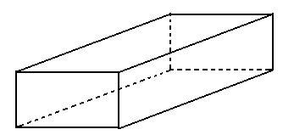
Pyramid | A three-dimensional figure with one base that is a polygon  (The other faces, called lateral faces, are triangles that connect each side of the base to the vertex.)  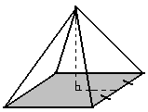
Quadrilateral | A four-sided polygon
Radius | A line segment having one endpoint at the center of the circle and the other endpoint on the circle
Reflections | Mirror images of a figure (Objects stay the same shape, but their positions change through a flip.)
Regular heptagon | A heptagon with all sides and angles congruent
Regular octagon | A octagon with all sides and angles congruent
Regular octagon | An octagon with all sides and angles congruent
Regular pentagon | A pentagon with all sides and angles congruent
Regular polygon | A polygon with all sides and angles congruent
Rotations | A transformation in which every point moves along a circular path around a fixed point called the center of rotation
Scale drawings | Pictures that show relative sizes of real objects

Secant | A line, ray or segment that intersects a circle at two points  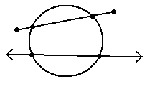
Similarity | The property of being similar
Similar polygons | Two polygons are similar if corresponding angles are congruent and the lengths of corresponding sides are in  proportion.  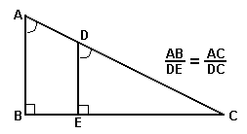
Sine | In a right triangle, the ratio of the length of the leg opposite the angle to the length of the hypotenuse
Slope | The ratio of the vertical change to the horizontal change
Slope-intercept form | A linear equation in the form y = mx + b, where m is the slope of the graph of the equation and b is the y intercept
Special right triangles | A triangle whose angles are either 30-60-90 degrees or 45-45-90 degrees  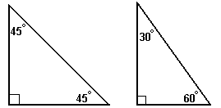

Sphere | The set of all points in space equal distance from a given point  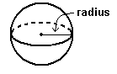
Standard form of a linear equation | The form of a linear equation Ax + By = C where A, B, and C are real numbers and A and B are not both zero  Ex. 6x + 2y = 10
Supplementary angles | Two angles whose measures add up to 180 degrees
Surface area | The area of a net for a three-dimensional figure
Tangent | In a right triangle, the ratio of the length of the leg opposite the angle to the length of the leg adjacent to the angle
Tangent to a circle | A line in the plane of the circle that intersects the circle in only one point  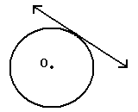
Tessellate | To cover a plane with a pattern of polygons without gaps or overlaps  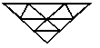
Theorem | A conjecture that can be proven to be true
Transformation | A change made to the size or position of a figure
Translation | A transformation that slides each point of a figure the same distance in the same direction

Transversal | A line that intersects two or more other lines in the same plane at different points  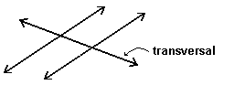
Triangle Inequality Theorem | The sum of the lengths of any two sides of a triangle is greater than the lengths of the third side.
Trigonometric ratios | The sine, cosine and tangent ratios
Venn diagram | A display that pictures unions and intersections of sets
Vertical angles | Non-adjacent, non-overlapping congruent angles formed by two intersecting lines (They share a common vertex.)
  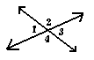 | ∠1 and ∠3 are vertical angles.  ∠2 and ∠4 are vertical angles.
Volume | The number of cubic units needed to fill a three-dimensional space

