Answer the following problems, documenting your solution using nouns, verbs, and –ly words.

- Name the three Boolean operators.
- Greater Than, Less Than, and Equal are what type of operators?
- When was the FPS Science Fair? Describe one of the projects.
- What other thing did Big Ben have to do with Computer Science?
- Use the scoring rubric from AP Questions V and VI to score this:
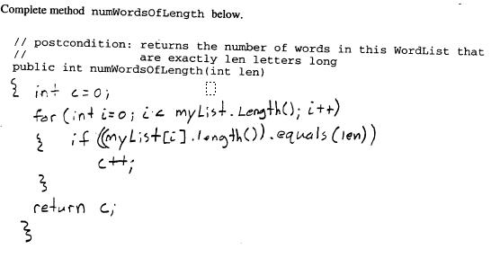
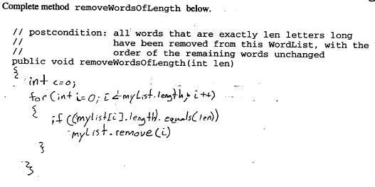
6. Consider the following code:

if (n > 10) System.out.print("*****");
if (n > 7) System.out.print("****");
if (n > 4) System.out.print("***");
if (n > 1) System.out.print("**");
System.out.println("*");

How many * will be printed when the code is executed

a) with n = 6 ?
b) with n = 20 ?
c) with n = 1 ?
d) with n = -1 ?

7. Explain this bit of code.
int s = 0;
int i = 1;
while (i <= 10)
{
s = s + i;
i = i + 1;
}
8. Explain this bit of code.
final int TRIES = 10;
for (int i = 1; i <= TRIES; i++)
{
int n = d.cast();
System.out.print(n + " ");

9. Using relational operators, formulate the following conditions in Java:

1) x is positive
2) x is zero or negative
3) x is at least 10
4) x is less than 10
5) x and y are both zero
6) x is even
10. What will be the next move?
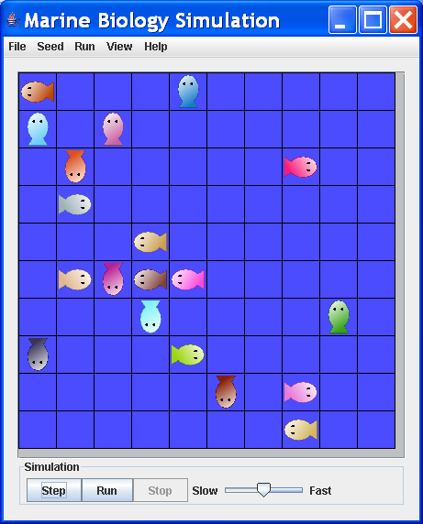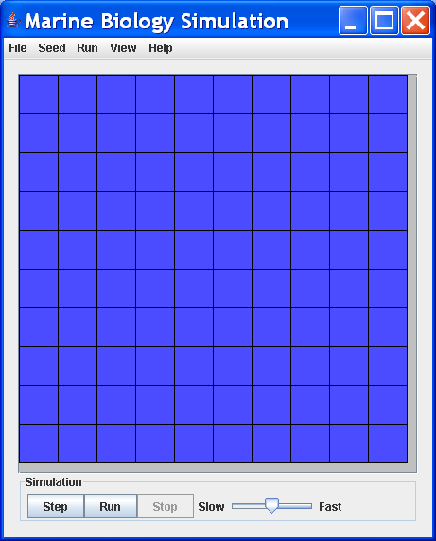
11. According to the following program, what color results when using the following inputs?
1) Y N Y
2) Y Y N
3) N N N

public class ColorMixer
{
public static void main(String[] args)
{
String mixture = "";
boolean red = false;
boolean green = false;
boolean blue = false;
String input = JOptionPane.showInputDialog("Include red in mixture? (Y/N)");
if (input.toUpperCase().equals("Y"))
red = true;

input = JOptionPane.showInputDialog("Include green in mixture? (Y/N)");
if (input.toUpperCase().equals("Y"))
green = true;

input = JOptionPane.showInputDialog("Include blue in mixture? (Y/N)");
input = console.readLine();
if (input.toUpperCase().equals("Y"))
blue = true;

if (!red && !blue && !green)
mixture = "BLACK";
else if (!red && !blue)
mixture = "GREEN";
else if (red)
{
if (green || blue)
{
if (green && blue)
mixture = "BLACK";
else if (green)
mixture = "YELLOW";
else
mixture = "PURPLE";
12. Using logical operations, express the following:

a) x and y are both positive or neither of them is positive.

Formulate the following conditions on the date given by the variables day and month.

b) The date is in the second quarter of the year.
c) The date is the last day of the month. (Assume February always has 28 days.)
d) The date is before April 15.
13. Which values of nyear cause the following loops to terminate?

/* Count the number of years from a user-input year until the year 3000.
*/

public static void main(String[] args)
{
int millennium = 3000;
String input = JOptionPane.showInputDialog(
"Please enter the current year:");
int nyear = Integer.parseInt(input);
while (nyear != millennium)
{
nyear++;
}

System.out.println(" Another " + (millennium - nyear) + "years to the millennium.");
System.exit(0);

}

14. What is the output of the following loop?

for ( i = 0 ; i < 5 ; i++ )
{
System.out.print(i + " ");
}

15. What’s wrong with this bit of code?
String input = JOptionPane.showInputDialog(
"Please enter your income:");
double income = Double.parseDouble(input);

input = JOptionPane.showInputDialog(
"Please enter S (single) or M (married)");
int status = 0;

if (input.equalsIgnoreCase("S"))
status = TaxReturn.SINGLE;
if (input.equalsIgnoreCase("M"))
status = TaxReturn.MARRIED;
else

16. What does this bit of code do?
final double FLUID_OUNCE_TO_LITER = 29586;
final double GALLON_TO_LITER = 3.758;
final double OUNCE_TO_GRAM = 28.3495;
final double POUND_TO_GRAM = 453.6;
final double INCH_TO_METER = 0.0254;
final double FOOT_TO_METER = 0.305;
final double MILE_TO_METER = 1609;

17. What is this bit of code for?
System.exit(0);

18. What’s wrong here?
double a = 0;
double b = 0;
double c = 0;
double discriminant = 0;
}

QuadraticEquationTest.java

/**
This program tests the QuadraticEquation class.
*/

import javax.swing.JOptionPane;

public class QuadraticEquationTest
{
public static void main(String[] args)
{
String input = JOptionPane.showInputDialog(
"Please enter coefficient a:");
int a = Integer.parseInt(input);

input = JOptionPane.showInputDialog(
"Please enter coefficient b:");
int b = Integer.parseInt(input);

input = JOptionPane.showInputDialog(
"Please enter coefficient c:");
int c = Integer.parseInt(input);

QuadraticEquation myEquation = new QuadraticEquation(a, b, c);

19. Do a Truth Table to verify that:
!(!A && B) = A || !B

20. Write the code for Hero’s square root algorithm. Test it.

