Answer the following using nouns, verbs, and -ly words.

1. Determine the missing values on the portfolios below and the grade on the fall final so that Tally can get a B for the semester with the least amount of effort. Explain your rationalizations. Assume no late charges.

 | 1st Quarter | 2nd Quarter
Overarching Process | 3 | 4
7 Systemic Parts of APCSA | 0
Your Ability to Test | 2 | 3
Growth | 4 | 2
Ability to Code |  | 1
Web Page/Free Choice | 2
Journal | 3 | 4

2. Given this system
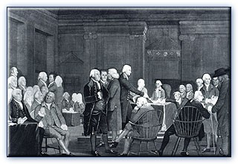
state 2 of the following:
• Entities

• Attributes of those entities
• Actions
• Interactions
• Information
• Relationships

3. Give the Constructor and Method Summary for one of the classes in ObjectDraw?
4. In the following line of code, explain the parameters and make a sketch of the figure:
clock = new FramedOval(15,22,22,22,canvas)

5. Discuss and report the comments you used in your Chapter 3 program.

6. Explain this segment of code:
input = JOptionPane.showInputDialog( "enter the weight of your favorite element according to your planner" );
_double = Double.parseDouble( input );
output = "weight of your favorite element is:" + _double;
JOptionPane.showMessageDialog( null, output,"element weight", JOptionPane.INFORMATION_MESSAGE );

7. Compare and Contrast Long and Short.
8. What’s wrong with this code?
Ellipse2D.Double circle1 = new Ellipse2D.Double(10, 10, 250, 250);
Ellipse2D.Double circle2 = new Ellipse2D.Double(35, 35, 200, 200);
Ellipse2D.Double circle3 = new Ellipse2D.Double(60, 60, 150, 150);
Ellipse2D.Double circle4 = new Ellipse2D.Double(85, 85, 100, 100);
Ellipse2D.Double circle5 = new Ellipse2D.Double(110, 110, 50, 50);

g2.setColor(Color.black);
g2.fill(circle1);
g2.setColor(Color.white);
g2.fill(circle2);
g2.setColor(Color.black);
g2.fill(circle3);
g2.setColor(Color.white);
g2.fill(circle4);
g2.setColor(Color.black);
g2.fill(circle5);

9. Explain this segment of code:
input = JOptionPane.showInputDialog( "enter Ability to Test grade (0-4)" );

grade = Integer.parseInt( input );
if (grade == 4){
test_total = 30;//for 4
}
else if (grade == 3){
test_total = 27;//for 3
}
else if (grade == 2){
test_total = 18;//for 2
}
else if (grade == 1){
test_total = 9;//for 1
}
else if (grade == 0){
test_total = 0;//for 0
}
else{
test_total = 0;//for everything else (there's mastercard)
}

output = "Your Your Ability to Test grade is (points):" + test_total;
JOptionPane.showMessageDialog( null, output,"the grade", JOptionPane.INFORMATION_MESSAGE );

10. Give the Pseudocode for your problem 11.

11. Write the code to produce the following scene:
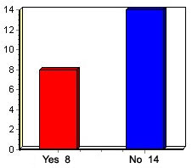
12. Convert the following:
Base 2 | Base 10
11
 | 111
101010
 | 10111
1000001
 | 222
 | 23

13. Give the fingers for one of the items from question 12 in base 2, 6, 16 and 10.

14. What happens when we start with Z in the game of life?

