WA-ILOU ANNOU with
alan monk (WA-ILOU ANNOU)
09/09/02 10:12AM >>>
How to fix the to import on tools Compile java,
Run text pad
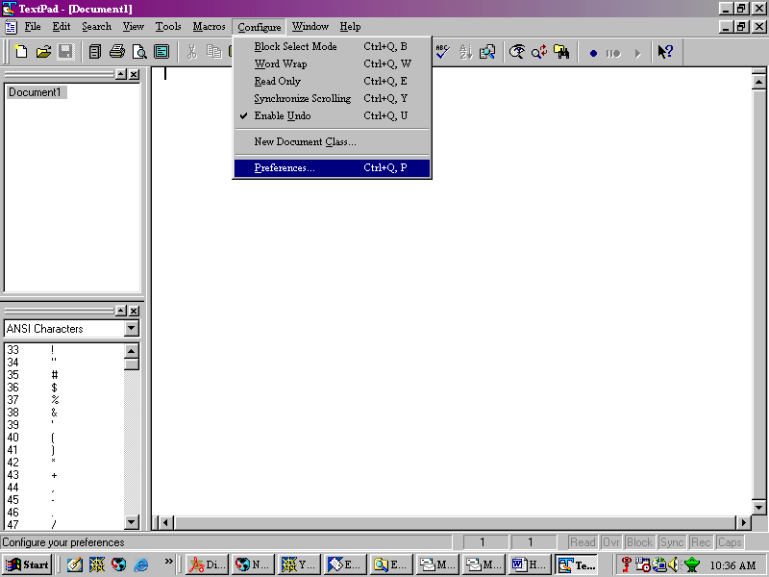

go to configure preferences
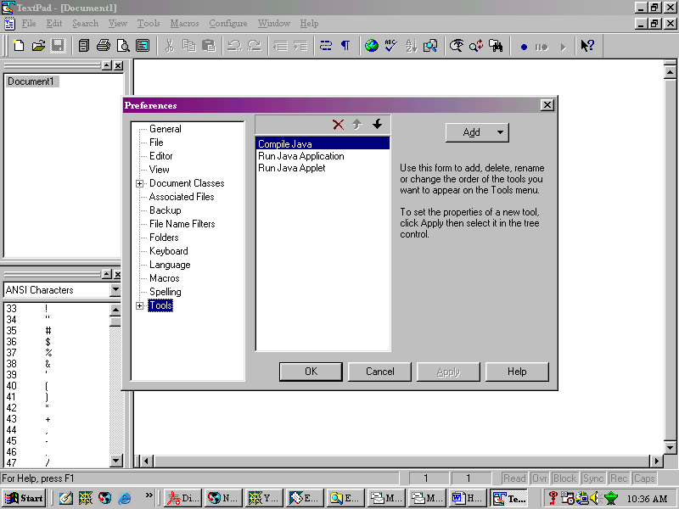
go down to tools
then to add
and go down to jdk commands
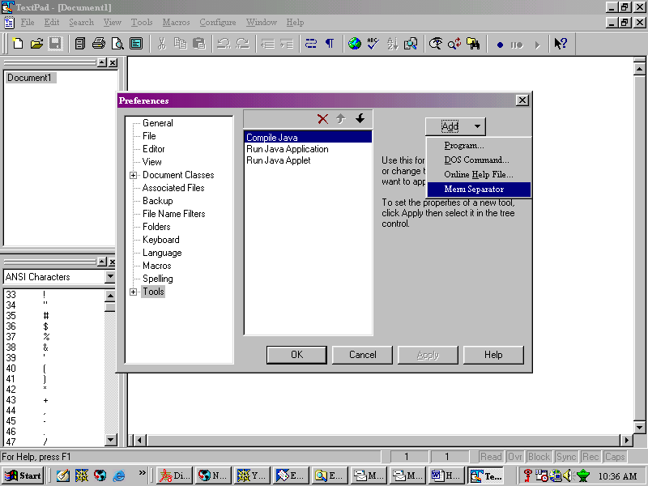
and u r done

