Answer the following using nouns, verbs, and -ly words.
1. Use a Portfolio Calculating Program to determine the grades from these Portfolios. Use Screen Shots to back up your answers. Determine the student’s average for the semester if she makes 37% on the Fall Final.
 | 1st QMT | 1st Q | 2nd Q MT | 2nd Q
Overarching Process | 2 | 3 | 3 | 4
Web Page/ Growth | 2 | 3 | 3 | 4
Systemic Parts of JAVA | 3 | 2 | 4 | 3
Your Ability to Test 7 | 2 | 4 | 3 | 2
Journal | 1 | 2 | 4 | 4

2. Modify the Rectangle applet and the web page to produce the following:
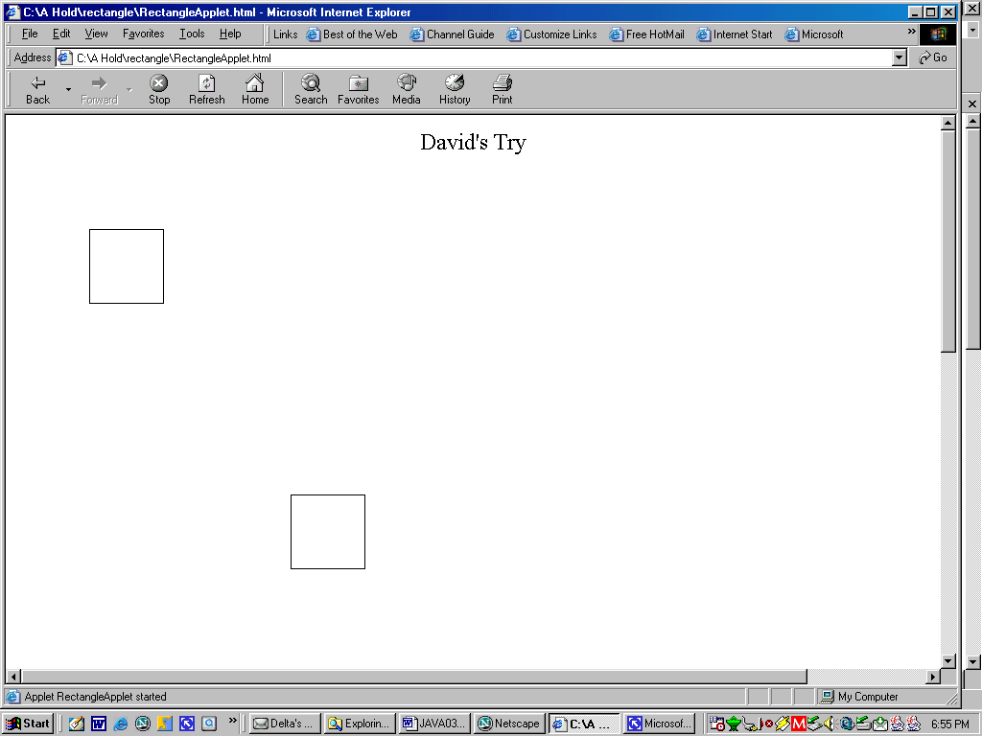
3. Explain at least three IO methods you know of for JAVA.

4. Change the name of the following program and variable(s) to create a program that will determine the sine of an angle given in degrees.
public class PrintSquare {
public static void main(String[] args) {
// A program that computes and prints the square
// of a number input by the user.
int userInput; // the number input by the user
int square; // the userInput, multiplied by itself
System.out.print("Please type a number: ");
userInput = TextIO.getInt();
square = userInput * userInput;
System.out.print("The square of that number is ");
System.out.println(square);
} // end of main()
} //end of class PrintSquare
5. What does the DoD have to do with the WWW?

<applet code="RectangleApplet.class" width="300" height="300">
</applet>
6. Why would this web page not work?

7. Explain this HTML code.

<p align="center"><img src="day.jpg" width="235" height="187">
</p>

8. Modify the ChartApplet to produce the following:
