NDPW {10 points}

Answer the following using nouns, verbs, and -ly words. {10 points}

As a team of two, or individually {10 points}, do one of the following programs:

I. Write the pseudocode {25 points} for a JAVA applet that would produce the following display with the Area in square centimeters in a web page. The program should include at least 5 of the following parts {25 points}:
+ I/O Methodology
+ Drawing Method
+ Logical Test
+ At least Three Primitive Data Types
+ Error Checking
+ Calculation
+ User Friendly
+ An Additional Programming technique
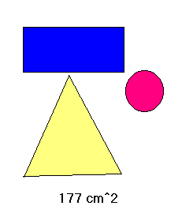
- Write the code {25 points} with comments {10 points}. In the code, document with additional comments the items that are listed above.
- Place the applet in a web page that includes some text for context {15 points}.
- Zip all the appropriate files and email to Coach Thompson {10 points}.

II. Write the pseudocode {25 points} for a JAVA program that would produce the results of at least three different calculations using some or all of at least 3 input values. The program should include at least 5 of the following parts {25 points}:
+ I/O Methodology
+ Math Method From Page 95
+ Logical Test
+ At least Three Primitive Data Types
+ Error Checking
+ Calculation
+ User Friendly
+ An Additional Programming technique
- Write the code {25 points} with comments {10 points}. In the code, document with additional comments the items that are listed above.
- Produce screen shots of the input and output {15 points}.
- Zip all the appropriate files and email to Coach Thompson {10 points}.

