- Suppose Mary wants to purchase an annuity that pays $1000/month for the next 20 years. The interest rate on this annuity is 6%. How much will she have to pay now to secure such an annuity?
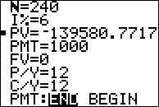
Calculate the value of $200 invested at 5%/year over 12 years.
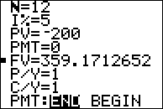
- Find the accumulated value of an annuity of $500 at the end of each month for 4 years at 9%/year compounded monthly.
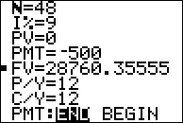
- Find the accumulated value on an annuity of $1500 per month for 25 years if interest is 12%/year compounded monthly.
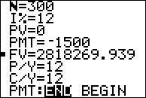
- Find the accumulated value of annual deposits of $100 for 10 years if the deposits earned 10%/year in the first 5 years and 12%/year for the next 5 years.
