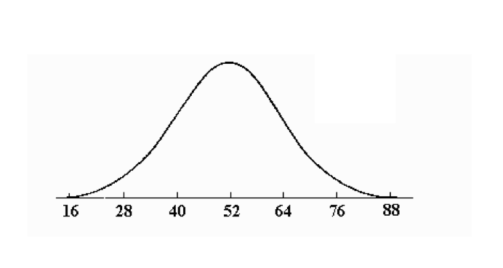
Normal Curve Worksheet Stat Name: ________________________________
+ 1std. dev. = 68%
Use the following bell curve: + 2std. dev. = 95%
+ 3std. dev. = 99.7%

- What percent of the data is greater than 52?
- What percent of the data is less than 52?
- What percent of the data is less than 40?
- What percent of the data is less than 28?
- What percent of the data is less than 16?
- What is the z-score of 16?
- What is the z-score of 28?
- What is the z-score of 40?
- What is the z-score of 52?
- What percent of the data has a z-score greater than 1?
- What percent of the data has a z-score greater than 2?
- What percent of the data has a z-score greater than 3?
- What percent of the data is in between 16 and 88?
- What percent of the data is in between 52 and 88?
- What percent of the data is in between 28 and 64?
- What percent of the data is in between 40 and 88?
- What percent of the data is in between 28 and 40?
- What percent of the data is in between 16 and 28?
- What percent of the data has a z-score between –3 and 3?
- What percent of the data has a z-score between –2 and 3?
- What percent of the data has a z-score between 1 and 3?
- What percent of the data has a z-score between –3 and 1?
- What percent of the data has a z-score less than 0.5?

