Three Ideas for a Project
Have you ever skipped class?
What political party do you identify with?
Democrat
Republican
Other
Would you ever vote for a woman as the president?
Probability with food and eating it
Probability with coins
Collecting data from students at fhs
Girls who wear makeup and don't wear make u
guys who play sports
girls in dawg crew
Rolling a die- the probability of it landing on a giving number
Out of 100 high school students- probability of student having a job.
Deck of cards- pulling at random, probability of being a face card or diamond card.
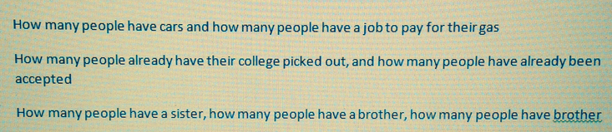
Survey - How many students have Xbox one's vs how many people have many students have PS4's
Experiment- If there are 100 cars in the senior lot, and 20 of them are Toyota's and 30 of them are Nissan's, what is the probability that you'll pick out a Chevy in the first row of cars?
How many juniors drive to school and how many seniors drive to school and does it affect their GPA by having more freedom?
The probability that someone likes gummy bears
the probability a student has a job,
the probability that someone has an iPhone
projected bets on winning the superbowl
best car brand
favorite console
favorite sport
least favorite school class
favorite color
how people feel about gay marriage and their age and see if there is a corrolation
how many peoples parents are divorced and their race and see if there is a correlation
if people still believe in true love and their age and see if there is a correlation
Ask if they will go to college after high school, take a few years off, or not go at all
Ask if they have a drivers license
Ask if which social media they use such as Facebook, snapchat, Myspace, etc.
flipping a coin 100 times
chances of getting a red m&m out of 200
pulling a card from a deck
The majority of Hispanics have construction jobs.
The majority of Hispanics are catholic.
The majority of white people are overweight.
Women get into wrecks more often than men.
The most frequent cause of wrecks is distracted driving.
There are more marijuana related arrests in California than any other state.
Girls eat ice cream when they're sad
Probability that junior males drive pick-up trucks
Southern men prefer horrible gas mileage in a large vehicle than being
in a small car
White guys cannot jump as high black guys
Probability that teenagers between the ages of 16 - 18 use a "card"
Probability that within the first year of obtaining a driver's license
a person will crash
Music Genres)
Pop - 1st choice
Pop-Rock - 2nd choice
Rock - 1st choice
Alternative-Rock - 2nd choice
Punk-Rock - 3rd choice
Grunge-Rock - 4th choice
Metal - 5th choice
Indie-Rock - 6th choice
Country - 1st choice
Folk - 2nd choice
Rap - 1st choice
Hip-Hop - 2nd choice
Classical - 1st choice
Piano - 2nd choice
Opera - 3rd choice
Symphony- 4th choice
Dubsteb - 1st choice
Techno - 2nd choice
Electronic - 3rd Choice
- List 2) Survey:
Candy Types)
Chocolate - 1st choice
Gummy - 2nd choice
Sucker - 3rd choice
Hard Candy -4th choice
Chewy - 5th choice
Gum - 6th choice
Mint - 7th choice
Rock - 8th choice
Jelly Bean - 9th choice
- List 3) Experiment:
Comparative Probability)
Rolling Different sided Dice
(4 Sided)
(6 Sided)
(8 Sided)
(10 Sided)
(12 Sided)
(20 Sided)
- Rolled with A die of Letters instead of Numbers in sets of trials
Survey- ask questions about a certain topic
Experiment- flipping a coin to see the result of heads and tails
Guessing the age of rappers
Would you rather drink Pepsi? Coke? or Neither? Using survey monkey.
Experiment: how many musicians are left handed?
Experiment: how many high school males have received speeding tickets?
Data Mining: what is the average time of high school girls' mile runs?
Would you rather be allergic to bacon or chocolate? We will use survey monkey.
how many students do we have each year
what Universities are each students going to and then make a graph about the results
how many students are in a club, different types of clubs
What is the probability that you drive and pay for your own gas?
What is the probability that you're a girl and is going to the U of A?
What is the probability that you're a guy and gets ready for school in 15 minutes or less.
Do you play sports? gender girl boy
What’s your favorite flavor of ice cream? boy girl
Do you pay for your own gas? sophomore junior senior
Which do you like better spring summer fall or winter?
Do you have your license? Girl or boy?
What’s the probability that you would choose Chocolate strawberry or vanilla?
Probability out of 200 that you will have a Red M&M?
What percentage of senior girls skip class compared to that of senior boys?
What percentage of Fayetteville high school students have jobs?
how many people prefer snickers over twix.
how many people sleep with socks on.
how many people listen to country music or rap.
2 candy bowls one with m&ms the other star burst probability of get one blue m&m and a yellow star burst
How many girls wear make up but don't dress up
How many guys are in band and a sporty
What's your favorite color?
A: Red, Purple, Blue, Green, Yellow
Are you against gay marriage?
A: Yes, or No
What are your thoughts about gay marriage and the government
How many people prefer a white board over a black board?
How many people prefer a laptop over a desk computer?
How many people prefer school Monday through Thursday rather than Monday through Friday?
The majority of Hispanics have construction jobs.
How many of Juniors and seniors like the same chocolate bar.
What is the probability the majority of the students here at FHS have a job.
How many boys and girls do or don’t have cars.
How many girls and boys have their nails painted orange or blue or no paint
How many girls and boys have red cars or black cars or no cars
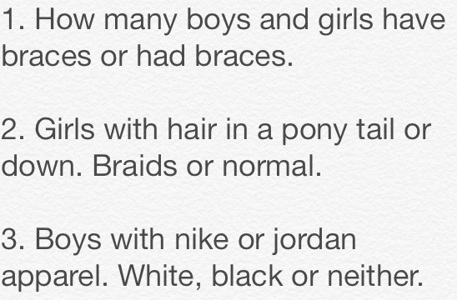
How many red cars go under a bridge in 30 mins?
How many people start walking with thier right foot?
How many people play flappy bird?
How many people bring water bottles to school?
How many seniors drive to school?
How many seniors go off campus for lunch?
How many people are failing at least one class?
How many girls have dyed their hair?
How many people IPhones?
Seeing how many people have are 6 feet tall and 165 pounds.
Dropping a dime in water and seeing if it turns up heads mostly.
Seeing that people like chocolate instead of gummy bears.

