Probability – Statistics Name ___________________________
Two-Way Tables
 | Heart | Not a Heart | Total
Face Card | 3 | 9 | 12
Not a Face Card | 10 | 30 | 40
Total | 13 | 39 | 52

- P(Not a Face Card)=P(C)=
- P(Spade, Club, or Diamond)=P(D)=
- P(C and D)=
- P(C or D)=

5. Shuffle a deck of playing cards and deal one card. Let event J = getting a jack and event R = getting a
red card.

- Construct a two-way table that describes the sample space in terms of events J and R.
- Find P(J), P(R), and P(J and R).
- Explain why P(J or R) does not equal P(J) + P(R). Then use the general addition rule to compute P(J or R).

6. The two-way table below describes the members of the U.S. Senate in 2008.

 | Male | Female
Democrats | 40 | 11
Republicans | 44 | 5

- Who are the individuals? What variables are being measured?
- If we select a U.S. Senator at random, what’s the probability that we choose
P(D) = P(female D)= P(female)= P(female or D
7. Students in an urban school were curious about how many children regularly eat breakfast. They conducted a survey, asking, “Do you eat breakfast on a regular basis?” All 595 students in the school responded to the survey. The resulting data are shown in the table below.
Eat breakfast | Male | Female | Total
Yes | 190 | 110 | 300
No | 130 | 165 | 295
Total | 320 | 275 | 595

- Who are individuals? What variables are being measured?
- If we select a student from the school at random, what is the probability that we choose

P(female)= P(eats breakfast)=

P(female who eats breakfast)= P(female or who eats breakfast)=
8. An American roulette wheel has 38 slots with numbers 1 through 36, 0, and 00. On the wheel, 18 of the numbered slots are red, 18 are black, and two – the 0 and 00 - are green. When the wheel is spun, a metal ball is dropped onto the middle of the wheel. If the wheel is balanced, the ball is equally likely to settle in any of the numbered slots. Imagine spinning a fair wheel once. Let event B = ball lands in a black slot and event E = ball lands in an even-numbered slot. Let event G = ball lands in a green slot. (Treat 0 and 00 as even numbers).
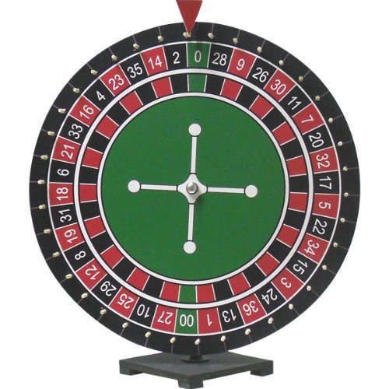
- Make a two-way table that displays the sample space in terms of events B and E.
- Find P(B) and P(E).
- Find P(B and E).
- Find P(B or E).
- Find P(B and G).
- Find P(B or G) using the general addition rule.
- Find P(E and G).
- Find P(E or G) using the general addition rule.

