Absolute Value Facts

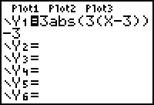
- To get the answer to the following questions, first key in the expression in □. Use the abs( function from the CATALOG. Press  [CATALOG] and it is the first option.
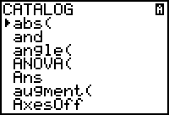
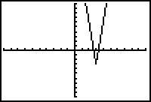
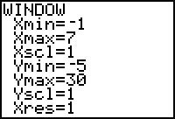
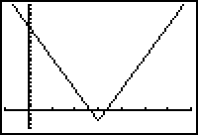
- Set the  using the   option, and the    if you cannot see the "V". Adjust the  manually until happy.

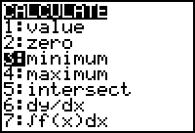
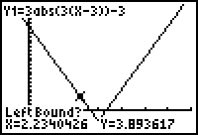
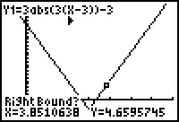
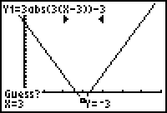
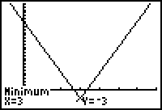
- To get the Minimum (or Maximum) select the appropriate option from the CALCULATE Menu. In this case  [CALC] . Answer the 3 questions and report the point.
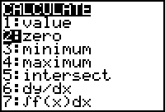
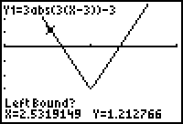
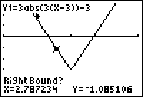
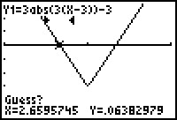
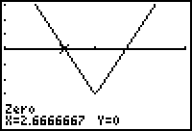
- To get the X-Intercept(s), follow the same procedure as above, selecting option 2:zero from the CALCULATE Menu. Press  [CALC] .

- To get the Y-Intercept, recall that the value of X at the Y-Axis is Zero, so select 1:value from the CALCULATE Menu. Press  [CALC]   .
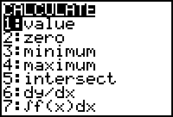
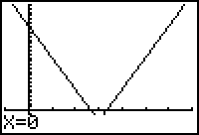
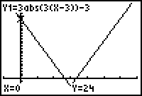

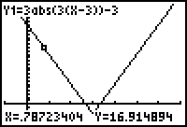
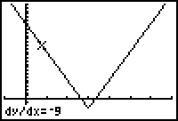
- For the slope, select option 6:dy/dx from the CALCULATE Menu, and then move the cursor to the side you want the slope of. Press  [CALC]     … . Repeat for the other side, as needed.
