A Functional Matter

Use the CBR to produce a graph of the letters of the alphabet. Paste each successful result (the graph) in a Word document. Full credit goes for the complete set of 27 letters. Your team should turn in one set of results with the team members listed and the letters identified. Email me a 15 second MPEG showing how to make one of the letters.
Set up the RANGER program with defaults (to start with). Either transfer the RANGER program from the CBR to your calculator (with about 10 000 bytes free), or use the CBL/CBR APP.
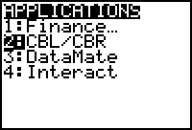 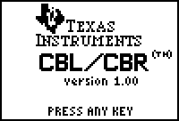 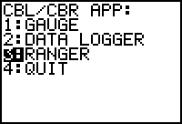
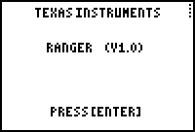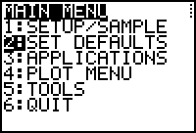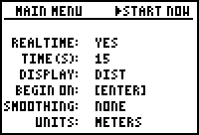
A | B | C | D | E | F | G | H | I | J | K | L | M
N | O | P | Q | R | S | T | U | V | W | X | Y | Z

