Answer the following problems, documenting your solution using nouns, verbs, and –ly words. Assume we want Square Windows.
- Give the equation in Standard Form of the circle, Center, and Radius if its diameter has endpoints of (7,-5) and (-6,4).
- Find the equation in Standard Form of this circle, and report the Graph, Center, and Radius:
- Give the intersection of these two circles:
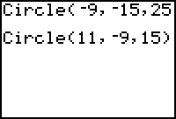 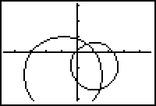
- Given the center (-11, 34) and radius (17) of a circle, report the Graph and equation in Standard form.
- Give the center and radius with a graph of this circle:
- Write this equation for a circle in Standard Form and graph it:

