In this investigation, an individual activity, you will explore the growth of an investment as it increases to twice its size due to accumulated interest.

1. Determine your initial investment by storing your phone number, with area code, in rand and then having the calculator select a random integer from 1 to 25. Report the phone number used. Multiply your number by $1000 to obtain your initial investment. This amount will be the Present Value (PV).
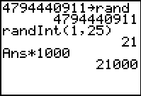
2. We want to collect information on how many years, and how many months, it will take to double your investment, as we vary the interest paid from 0.25% to 12.5% by fourths. Your three Lists will be Interest, Years to Double, and Months to Double.

3. Create the values for interest in a list using the seq( function as shown below.
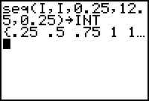

4. To collect the information on how long it takes to double your money, use the FINANCE App and the TVM Solver. You will need to set the values for I% in percent form for your interest rates (that is 5% would be 5, not 0.05), PV is the present value, from part 1, and will be negative to reflect cash output, PMT is the payment which will be zero in this problem, FV (future value) should be double the PV (but positive due to the fact that this will be cash return. P/Y is the number of payments per year, and C/Y is the number of compounding periods per year. To get the value in months, use 12 for both P/Y and C/Y and then solve for N. Get the number of years to double from N divided by 12.
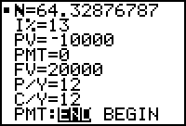

In the example above, the random integer was 10 ($10,000), the interest tested for is 13% and the value of N is 64.33 months to double. So the data entered to the lists would be I = 13. Month = 64 and Year = 5.4.

5. Perform this process for all fifty values for interest.

6. Do a Scatter Plot of the data and determine the function for the Time (in months, and then in years) as a function of Interest rate.

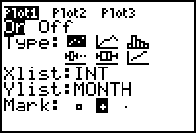

7. Compare your function to A = A_{o}*e ^{r*t} where A is the amount of money yo u have at any given time, A_{o} is the initial investment, r is the interest rate, and t is the time in years.

8. Look up the “Rule of 72" or "Rule of 70" and compare it to the function(s) that you determined.

9. Explain why the “Rule” works.

