Answer the following and document your solution. Use nouns, verbs, and ly-words.
- Digitize a part of the Arthur Andersen logo and create a set of piecewise equations for this part.

- Use your Slide Bar in TII and fill in the table below.
Vertex: | Standard: | Intercept: | A | B | C | h | k | P | Q
- Complete the Square to solve the following:
- When is the difference between R and R³ the greatest? Show this graphically.
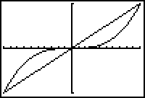
- Find a pattern (function) that will generalize the result of an infinite number of the following actions.
- Give the function that best represents the pattern shown in the following data. Use the form
y | -895 | -836 | -779 | 5 | -524 | -251
x | -175 | -170 | -165 | -25 | -140 | -105

