Answer the following problems, documenting your solution. Use nouns, verbs, and –ly words.

- Digitize this image. Give the piecewise function that models the image. Determine the area of the image.
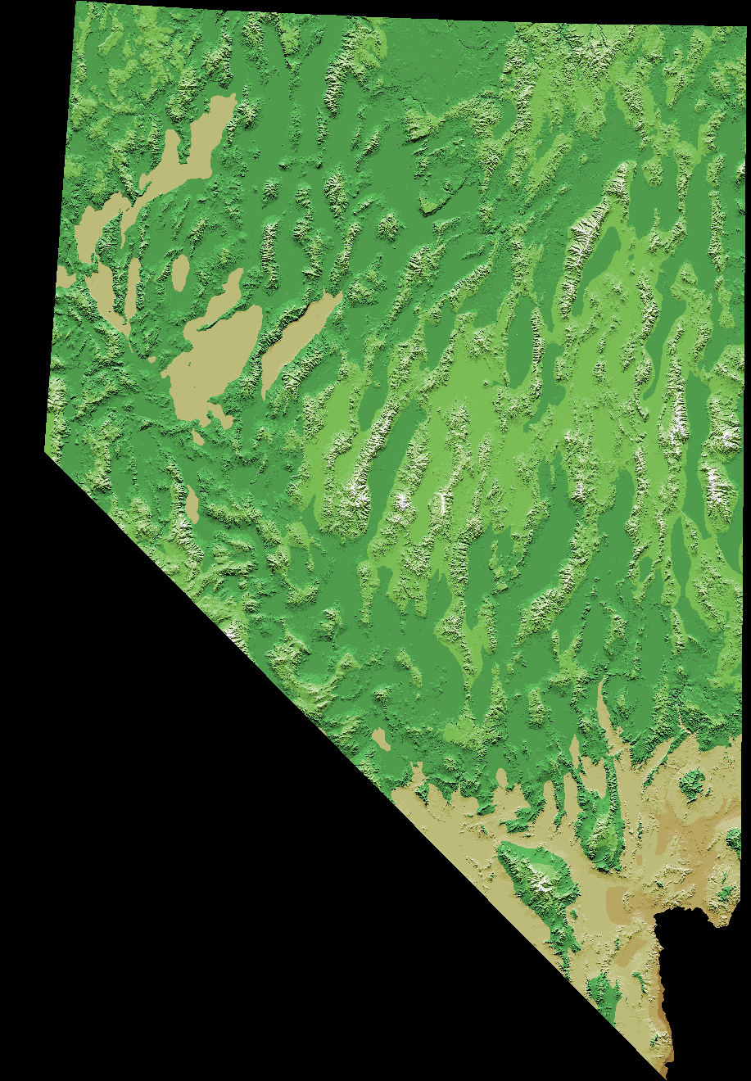

- Calculate the grade of the person who made the following score on their Portfolio.
 | 1st Q Mid
Overarching Process | 3
7 Systemic Parts of PreCalculus | 2
Your Ability to Test | 2
Web Page/ Growth | 4
Journal | 2
- Explain why it is hard, if not impossible, to make a letter that does not represent a function when using the motion detector (CBR). Use an example.
- Solve this system of equations and state the method used. Use two different methods.
- Determine the solution to the following:
- Graph, using a square setting:
- Solve for x:

