A Sine of The Time!

In this investigation you and your team will collect the heights above the floor that the minute hand is as it moves around the clock face for three hours. This information will be graphed, and you will determine the best function to model the pattern in the data.

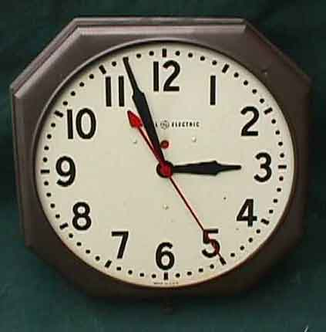

Team Members: __________________________________________________________________________________________________________________________

1. Place the clock on the wall, and attach the CBR to a Meterstick with a clamp. Place the Meterstick parallel to the floor at the heights indicated by your assigned times with the "eye" of the CBR facing the floor.

2. Run the CBL/CBR APP and use GAUGE. Set the Range of values to an appropriate set of values, and measure in meters. Report your settings.

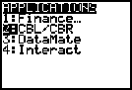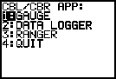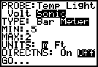

3. Start at your assigned time: 1AM, 2AM, 3AM, 4AM, 5AM

4. Use the assigned step. Collect data every:
7 min, 8 min, 9 min, 11 min, 13 min.

5. Record the data for Time and Height for at least the next 3 hours in the table below.

Time of Day | Height (m) | Time of Day | Height (m)

6. Plot the data with Time in hours as the Independent variable (x) and Height in centimeters as the Dependent variable (y). The data is stored in your calculator in the List DREF and DIST. Hint: show 2:12 AM as 2.20 hours.

7. Determine the type of function that is exhibited by the graph and state the function with the constants identified.

8. Now state the equation in the form y = A cos (B( x - C )) + D.

9. Describe the significance of A, B, C, and D include units.

10. Give a graph with the cosine equation and a scatter plot of the data.

