

Interpreting Motion Graphs!

So, having a little trouble interpreting Mr. Young’s brain-busting motion graphs? So did I! But I figured out a couple of simple ways to understand and be able to give the answers he is looking for! So let’s get started.

-----------------------------------------------------------------------------------

So what if Mr. Young gives you an equation? Something like: 2x³+3x²+4. Then he says this is the distance equation of the moving object, find the velocity and the acceleration. Well for those of you who know calculus, this is easy!! All you have to do is take the first derivative to find the velocity and then take the second derivative to find the acceleration.

Example:

Distance: 2x³+3x²+4
Velocity: dy/dx = 6x²+6x
Acceleration: d²y/d²x = 12x+6

The pictures of those graphs may be as follows:

Distance Velocity Acceleration
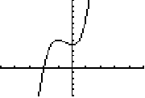
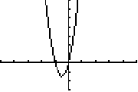
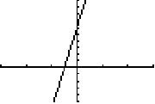

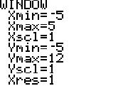
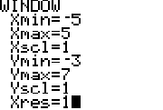
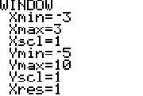

-----------------------------------------------------------------------------------------------------------------------------
Well for those of you who aren’t in calculus, those equations probably look like Greek to you. Let me show you another way to do this. And since Mr. Young doesn’t usually work with numbers and equations, we’ll use graphs and pictures this time.

Let’s say you’re given a graph like this, which is labeled distance vs. time graph:

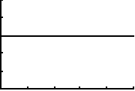
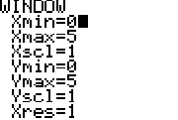

Basically to answer these, you just have to use the intuitive side of your brain.
Think like this: if this graph shows that the object stays at a distance of 3, then the object isn’t moving. Therefore the velocity is zero, and the acceleration is also zero. Both of the graphs would look like this:

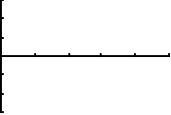
Just change y-min to –3 and y-max to 3.

There you go! Now was that so hard? Ok but what if you’re given a graph that looks like this?
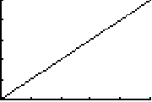
This shows that the distance is steadily increasing.
Intuitively this would mean the velocity is positive and that means that the velocity is not increasing therefore meaning that the acceleration is zero.

The graphs are as follows:

Velocity Acceleration
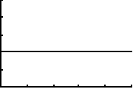

Now see? Is it that bad? Here are some other problems to try, find the velocity and acceleration graphs:

Distance #1 Distance #2
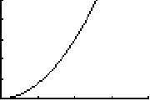
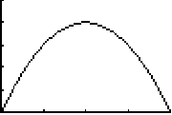

Answers:

Velocity #1 Velocity #2
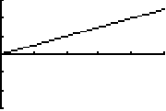
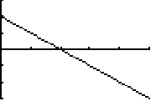

Acceleration #1 Acceleration #2
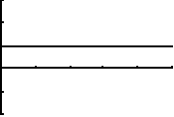
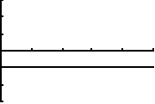

So there are a couple problems. If you still need some help or extra practice with using these, then go to the following websites:

- Kind of a complex site but check it out!
- Really neat site that has to do with speed
- If you need practice, here’s a worksheet
- This helps with calculus but it has pretty graphs
- Neat informational sight
- An interesting sight, trying searching it for other subject related help
- Good animation of what happens with motion graphs (wait for the pics to load.

Application in the real world:

Commercial vehicles are required, by law, to carry and use a tachograph. This looks like a slightly larger than usual speedometer and has a piece of circular graph paper mounted beneath the speed indicator. When the vehicle is driven, the speed is constantly recorded as a line on the chart. In the event of an accident, or the possibility of the driver exceeding a speed limit, the graph provides an immediate check on the vehicle speed. The device records the hours that the driver has worked and the time on the road and resting. Drivers are required to stop for rest breaks after a period of driving. Tampering with the chart (or removing the paper, replacing with a second copy etc.) is a serious offence. {This information can be also found on the SPEED website}

My name is Adrianne Mikles and I made the website on motion graphs because, I figured since it was something that I had trouble with, maybe I could learn more if I did more practice and work on the subject. I thought I could also help others having the same sort of trouble. If you would like to contact me email me at zuzus24@aol.com .





