Answer the following problems, documenting your solution using nouns, verbs, and –ly words. {10}

1. Make a Force Diagram for the following situations {15}:
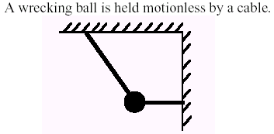
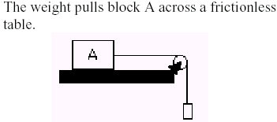
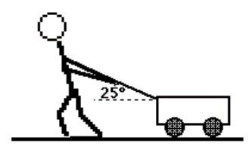

2. In the first situation above, give equations for the x and y components of the forces {10}. Show your work {5}, and simplify the expressions {5}.

3. Given the following values from the experiment with the ramp in Lab I. Give the best-fit function {10} and graph {10} that models the Force and Angle relationship.
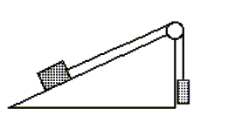

Angle in Degrees | Force Reading on the Probe (N)
10 | 4.34
15 | 6.47
20 | 8.55
25 | 10.57
30 | 12.50
35 | 14.34
40 | 16.07

4. In question number 3, what is the value of the mass on the ramp? {10}

5. Given the following data from Lab I, find the conversion from mass to force {10}, and tell what planet do you think you are on?{10} Explain. {5}
Mass Supported  by the Probe (g) | Force (N)  Recorded
250. | 2.21
500. | 4.41
750. | 6.62
1000. | 8.83
1250. | 11.04
1500. | 13.24
1750. | 15.45
Planet | Percent of g
Mercury | 0.378
Venus | 0.907
Earth | 1
Mars | 0.377
Jupiter | 2.364
Saturn | 0.916
Uranus | 0.889
Neptune | 1.125
Pluto | 0.067

6. In the situation below, determine the magnitude of the forces when the angle indicated is 15 degrees, for the rope that is hooked to the ring. {15}.
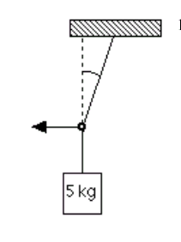

7. Given the ramp below, explain how you might determine the coefficient of friction of the surface. {10}

