I. Build the parametric equations to model the types of motion on your calculator. Save as GDB as needed.
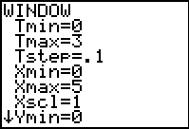
Spike and Wall:
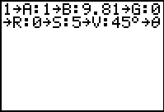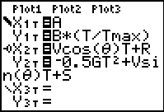
Table:
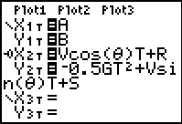
Monkey:
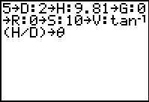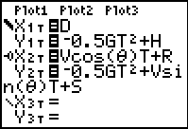
Drop and Throw Down/Up:
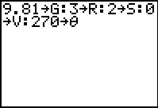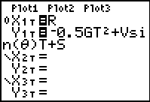
II. Create 6 slide bars in TII and adjust the values to an appropriate range.
X₀, Y₀, Targetx₀, Targety₀, V₀, θ. Assign a value for g. Setup the parametric pairs for the event. Make them Bubble Baby. Test the graphs for the different types of motion.

III. Model these problems with parametric equations in TII and/or on your calculator.
A) The movie "The Gods Must Be Crazy" begins with a pilot dropping a bottle out of an airplane. A surprised native below, who thinks it is a message from the gods, recovers it. If the plane from which the bottle was dropped was flying at a height of 500m, and the bottle lands 400m horizontally from the initial dropping point, how fast was the plane flying when the bottle was released?

B) Suppose a metal sphere is launched up a ramp with V₀ = 1.5 m/s. The end of the ramp is 1.20 m above the floor. Calculate the range of the sphere. Would the sphere make it over a meter high wall located at a distance of 3 meters from the end of the ramp? What initial velocity would make it just clear the wall?

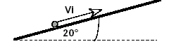

C) A monkey is hanging from a limb high up in the canopy of a rain forest. The height of the monkey above the ground is 77 meters. A hunter with a tranquilizing dart in a blowgun aims directly at the monkey. The horizontal distance from the hunter to the tree is 1001 meters. At the exact moment that the hunter blows the dart out of the gun the monkey sees it and lets go of the branch. Find the range of values for the initial velocity that will get the dart to the tree, the angle that the dart is launched at, and the location that the monkey is when the dart hits, for one selected value of the initial velocity.

