Answer the following problems, documenting your solution. Use nouns, verbs and –ly words.

- For the following graph, tell of an event that would produce the pattern shown, and give an equation for that pattern. Report the measures and the units for the independent and dependent variables.
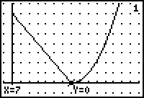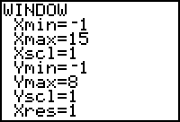
- What is the Fermi mass in slugs of the population of the world?
- In playing the Free Fall game with a group of aliens who are about 200. meters tall, what reaction times would you expect if they were trying to catch a 1957 Chevy? Explain.
- Given the following data set answer these questions:
feet/sec | 1.75 | 25.0 | 0.300 | 111 | 541 | 225 | 77.0
meter/sec | 0.539 | 7.77 | 0.111 | 34.1 | 160. | 66.6 | 23.9
- What does the data indicate about the conversion rate from feet per second to meters per second?
- Use that conversion to convert the following:
99 fps, 7 fps, and 3200 fps
- Give and equation for the conversion from fps to mps.
- What is the True conversion rate? Use it to convert the values in question b). How close were you with your conversion rate?
- Answer one of the following:
a) How many barns on a dime?
b) If a nickel were stretched to a length of one mile, what would its density be in texs?
c) How many gills in a full 3-liter bottle of very-very old Diet Dr. Pepper?
d) How many alens in a 150 cm tape measure?
- When is the equinox?
- What was the ether that Count Rumford was dealing with?
- Why do you think you got the reply that you got from your email about the Gravity Waves?
- What is wrong with this?
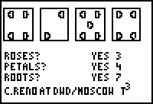
- Linearize this data to determine the type of function. Get the linear equation, and then create the real model from this function.
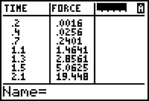
- Given the following information relating GPA and hours of study per week for school, answer the questions.
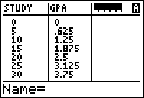 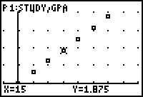
a) What are the units of the slope of the graph?
b) What is the mathematical equation that states the relationship described by the graph?
c) What number of hours of study would predict a GPA of 4.11?
- Find the function that best fits the pattern shown in this sunrise/sunset data. Report the Amplitude, Vertical and Horizontal shift, and Period.
Collect the information from the PHYQ112 program.
Day Of Year | Sunlight |  | Day Of Year | Sunlight
1  30  60  80  120  150  172  180 | 11.60  11.68  11.87  12.00  12.25  12.37  12.40  12.40 |  | 210  240  264  270  300  330  355  365 | 12.30  12.15  11.98  11.95  11.77  11.63  11.58  11.58

