1. Draw a force diagram to represent the situation below. The box slides down the ramp at constant speed.

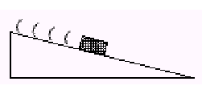

2. Determine the x and y components of the force vector below. Show work.

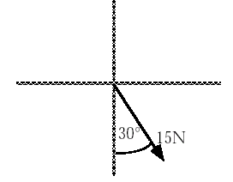

3. Write the equations for the sum of the forces acting in the x and y directions for the junction of the cords in the diagram below.

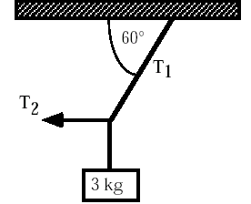

Bonus: Find the values of T1 and T2.

