Answer the following problems, documenting your solution using nouns, verbs, and –ly words.

1. Make a Force Diagram for the following situation

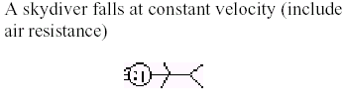

2. Given the following values from the experiment with the ramp in Lab I. Give the best-fit function and graph that models the Force and Angle relationship.
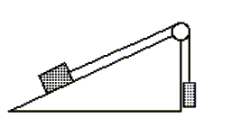

Angle in Radians | Mass Equivalent of the Probe Reading (g)
0.10 | 78.0
0.20 | 154
0.30 | 230.
0.35 | 265
0.40 | 300.
0.50 | 375
0.60 | 440

3. If your target was 7.3 meters away from the table, and the table was 27 centimeters tall, how long was it from the time the ball left the table, to the time it hit the ground? What was its initial velocity? What was the final velocity?
4. An 11.0 kg sign hangs from a boom supported by a cable connected to a wall. The cable makes a 45-degree angle with the boom. Sketch a force diagram for the sign. What is the force of tension in the cable? What force does the boom apply to the sign?
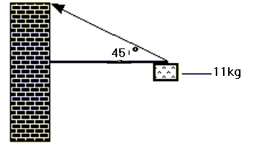

5. If the k-value of a spring is 540 N/m, graphically determine the work needed to stretch it from 0.0 meters to 5.0 meters.
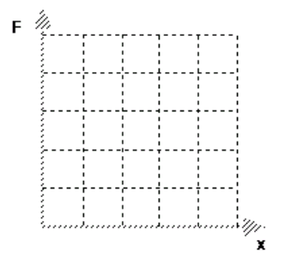
6. Use the following data from the Hook’s Law lab to answer these questions:
Displacement (m) | 1.00 | 1.25 | 1.35 | 1.50 | 1.75 | 1.80 | 1.90
Force (N) | 0.0 | 800. | 1100. | 1600. | 2400. | 2500. | 2900.
- What is the k-value for the spring?
- How much energy is released when moving the spring from the 1.40 meter mark to the 2.00 meter mark?
- What force is needed to stretch the spring 3.00 meters?

7. Create an original question for each of the following graphs that would use the use of the area or the slope from the graph as part of the solution. State your answer for each question.
