Answer the following problems, documenting your solution using nouns, verbs, and –ly words.

1. Sketch the graphs of the following, for the conditions given:
- Force vs. Inverse of the Mass with a constant Acceleration.
- Acceleration vs. Force with a constant mass.
- Acceleration vs. Mass with a constant Force.
2. The following is a graph of a Resource Room Officer’s car.
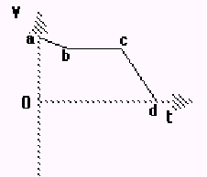
Determine the following:
- Sketch the position vs. time graph.
- Sketch the acceleration vs. time graph.
- The nature of the motion from points a to b.
- When, if ever, is the net force on the car zero?
- Where is the net force on the car the largest?
3. If the apparatus below depicts a frictionless surface with Block A having a mass of 125 kg, and Block B with a mass of 25 kg, determine the following:
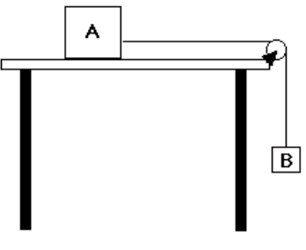
- Draw a force diagram for each block.
- Determine the acceleration of the system.
- What is the tension in the string?

4. Use a Force diagram to explain why we needed to keep the force probe parallel to the surface in Lab 2: Friction.
5. Explain the three experiments that you did at the Jones Center. Tell why you picked them, what data was collected, and how it was collected, and your hypothesis.
6. A 140. Kilogram box is pulled across a frictionless surface by a 600.0 Newton force at an angle of 30.0 degrees as shown below. Draw a force diagram for the box. What is the acceleration of the box in the x-direction? What is the Normal force on the box?
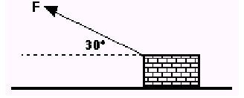

7. Sketch the graph of velocity vs. time; acceleration vs. time; or force vs. time for an elevator moving from the 1st floor to the 3rd floor.
8. A helicopter is accelerating at -1.25 m/s/s. If the mass of the chopper is 4705 kilograms, what is the force of the blades on the air?
9. A cart with a mass of 114 kilograms starts from rest and travels 4.7 meters in 2.5 seconds. The cart is uniformly accelerated during this time. What is the net force acting on the cart?
10. What does it mean to have a constant force? Explain.

