Now we want to “know” the initial velocity of your dart from Lab 3. To do this, we will use a photogate probe with the DATAGATE program on your calculator and the CBL2/LabPro.

Set up your mechanism and place the photogate so that your dart will pass through the beam of the probe. You will need to set the program to use one photogate and then report the length of the dart in meters.

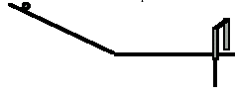

Run each event as many times as you need to determine the “True” time for the dart to pass through the beam.

Use the setting nomenclature from Lab 3 for the Gun Setting in the table below. Fill in the table for 7 different distances of the target. Report the height of your table, with the other relevant parameters.

Target Location | Gun Setting | Predicted V₀ | Time from Photogate | Calculated V₀ | Percent Error

Calculated V₀=

Percent Error =

