We will now return to the Elevator and ride between floors. In this event we will travel from the 3rd floor to the 1st and then from the 1st to the 3rd.

- Set up the Low-G Accelerometer and the Force probes in Channel 1 and 2 respectively on the CBL2.
- Calibrate each probe. Use the method for the Accelerometer that has the arrow pointing down = - 9.81 m/s/s and the arrow up = 9.81 m/s/s.
- Set up the Mode to a state that you feel will be best for the trip down. The time to get up and down in the elevator for the 3 floors should be the same, so the setting on the return trip should be the same.
- With the arrow on the Accelerometer point toward the 1st floor, and with a known mass of approximately 9 Newtons hanging from the Force probe. Get in the elevator and press the 1st floor option. As the doors close START the experiment. If you like the results, proceed to the graphing part below. If you are unhappy, return to the 3rd floor, modify the MODE and/or the positioning of the probes, and repeat the trip to the 1st floor.
- Provide graphs for the experience of the trip down on the graph below, Using (+++) for Force, and (000) for Acceleration. 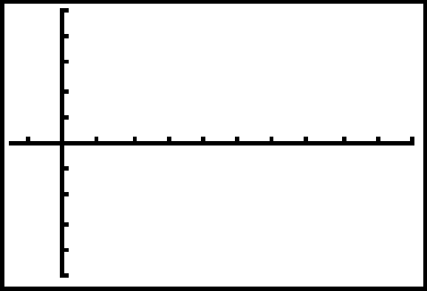
- Under the option of SETUP save the experiment. Repeat the data collection using START from the main menu this time traveling from the 1st floor to the 3rd. If you are happy with the results, proceed to the graph below. If you are unhappy, return to the 1st floor and try again. Hold the probes in the way that you used for the trip down.
- Provide graphs for the experience of the trip back up on the graph below, Using (+++) for Force, and (000) for Acceleration.
- Write a summary of the event as it related to the concept of Constant Force. How is it that there are four parts for the round trip?

