With your assigned team, verify your solution to your assigned question using the materials the Mr. Young has provided. Use scaled masses/weights. Create a WhiteBoard to explain the question and your solution with verification procedures.

Team | To Verify
DEATON, KATHLEEN | 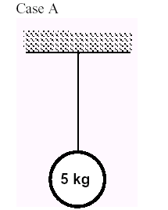
DUELL, HANNAH  SHACKELFORD, SPENCER | 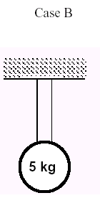
YOUNG, ASHLEY  WALKER, DANIEL | 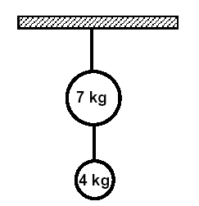
BATES, TREVOR  MORRIS, RACHEL | 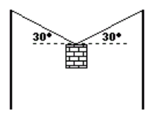
GULLEY, LATOYA  TAYLOR, JON | at 5°
BYRAM, KEVIN  JENKINS, SAMIR | 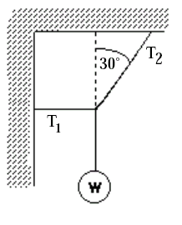
TRULLEY, ANANDA  FRENCH, AARON | 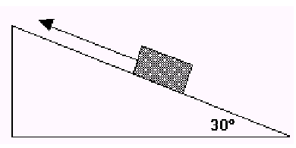
ROE, COLIN  HAYWARD, JOHNATHAN | 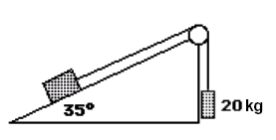
HARRIS, JOHN  CARTER, MEGAN | 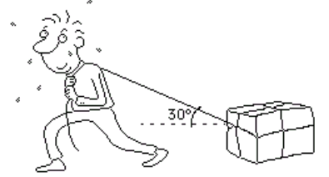
LYNCH, BLAIR  MIKLES, ADRIANNE | 

