Answer the following problems, documenting your solution using nouns, verbs, and –ly words {10}.
- Seed your random number generator with your date of birth in the form mm – dd – yy. Report these values {5}. Use randInt to create a value for g from 111 to 1300 cm/s/s inclusive {5}. Use it {5} to determine if you would play someone with a reaction time of 0.144 seconds, using a $5 bill {5}.
- For this clock, we have the following data showing the height of the end of the minute hand above the ground at each time. Create a Plot {10} of Height in meters vs. Time in hours. Get the function {5} in the form of y = A * cos (B * ( x – C )) + D. Use slope key on your calculator to find the maximum or minimum slope and give the Time {5}, Height {5}, and magnitude {5} (with units and sigfigs) of the slope(s). Identify the values of A, P, C, and D with the units and sigfigs {20}.
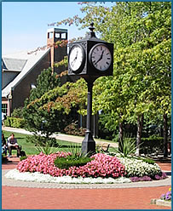
Time  (Hours) | Height  (m)
3:00 PM | 8.25
3:11 PM | 7.51
3:33 PM | 5.81
4:06 PM | 8.01
4:17 PM | 6.74
4:39 PM | 6.27
4:50 PM | 7.62
5:12 PM | 7.39
5:23 PM | 6.07
5:34 PM | 5.86
5:45 PM | 7.00
5:56 PM | 8.14
- Use one of the methods (Graph It, Using Geometry, Components, Calculator, or Science Tools) {10} to solve this vector problem {10}:
You are traveling with a velocity of 201 kilometers per hour at 211° with a wind blowing 37.0 kilometers per hour at 301°. What is the resulting velocity?

