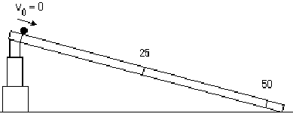

After the demonstration, answer these questions:
- What do you observe?
- Describe the motion.
- From the two previous answers, list all of the things that one could measure.
- How can you measure speed directly?
- Make a Motion Map of the event.

