Answer the following problems, documenting your solution using nouns, verbs, and –ly words.
- Seed your random number generator with your date of birth in the form mm+dd+yyyy. Report this value. Use randInt to create a value for g from 1 to 55 inclusive. Use it to determine if you would play someone with a reaction time of 0.11 seconds, using a $2 bill.
- For this clock, we have the following data showing the height of the end of the minute hand above the ground at each time. Create a Plot of Height in cm vs. Time in hours. Get the function in the form of
y = A * cos (B * ( x – C )) + D. Use slope key on your calculator to find the maximum and minimum slope and give the Time and magnitude (with units and sigfigs) of these slopes. Identify the values of A, B, C, and D with the units and sigfigs.
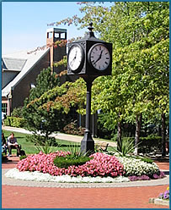
Time  (Hours) | Height  (cm)
3:00 AM | 1012.5
3:17 AM | 1003.4
3:34 AM | 998.2
3:51 AM | 1009.4
4:08 AM | 1010.0
4:25 AM | 998.5
4:42 AM | 1002.7
4:59 AM | 1012.5
5:16 AM | 1004.2
5:33 AM | 997.9
5:50 AM | 1008.8
6:07 AM | 1010.6
- Use one of the methods (Graph It, Using Geometry, Components, Calculator, or Science Tools) to solve this vector problem:
You are traveling with a speed of 38 kilometers per second at 295° with a wind blowing 7.7 kilometers per second at 25°. What is the resulting velocity?

