American Government: Magruder’s American Government, by William A. McClenaghan; Needham, Mass.: Prentice Hall, 2008, ISBN 0-130181897-X Chapter 18 through Chapter 25, (Pages 506-745). Contact: James Grey, 501-766-8386 or 800-552-2499

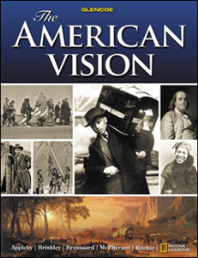
American History, American Vision, by Appleby, Brinkley, Broussard, McPherson and Ritchie, Glencoe/McGraw Hill 2008. ISBN 978-0-07-879701-9, Chapter 1 through 8, (pages 2-307 ). Contact: Mary Jane Atwood, 501-352-4757.

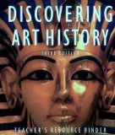
Art History: Discovering Art History, 3rd edition by Gerald F. Brommer; Davis Publishing Inc.: Worchester, Mass 1997, ISBN 87192-300-9. Chapter 14 through Chapter 17 (pages 448-586) Contact: 800.782.4479 or 800.951.3654 (Phyllis Tucker)

Biology: Biology: Concepts and Connections, 5th edition by Campbell, Reece, Taylor, and Simon, 2006, Pearson Benjamin Cummings, 1301 Sansome St., San Francisco, CA., 94111. ISBN 0-13-193480-5. Chapter 1 through 10. (Pages 1-205 ). Contact: James Grey, 501-766-8386 or 800.354.9706

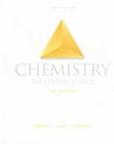
Chemistry: The Central Science , 10th edition, by Brown, LeMay, Bursten, 2006, Pearson Education, Inc., Upper Saddle River, NJ 07458. ISBN 0-13-193719-7, Chapter 1 through 6 (Pages 1-249 ). Contact: James Grey, 501-766-8386.

World History: World History, by Spievogel, Glencoe, 2008. ISBN 978-0-07-874526 Chapter 17 through 23 (pages 536-783). Contact: Mary Jane Atwood, 501-352-4757.

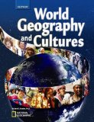
Geography: World Geography and Cultures, by Richard G. Boehm, PhD.; Westerville, OH; Glencoe/McGraw Hill, 2008. ISBN 978-0-07-874529-4. Chapter 5 through 10, (pages 130-254 ). Contact: Mary Jane Atwood, 501-352-4757.

Physics: Physics, by Serway and Faughn; Holt Rinehart and Winston, 10801 North MoPac Expressway, Building 3, Austin, TX.78759, 2006, ISBN 0-03-073549-1, Chapter 1 through 5, (pages 4-175 ). Contact: Mary Jane Atwood, 501-352-4757.

Shakespeare: The Complete Works of Shakespeare, updated 4th edition, David Bevington, University of Chicago, Addison-Wesley Educational Publishers, Inc., Longman, Inc. ISBN – 0-673-99996-3. As You Like it, The Tempest, Richard III, Julius Ceasar.

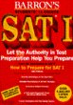
Vocabulary: SAT I, Barron’s, 18th edition, 1994. ISBN 0-8120-1856-7.Word list 11 thru 15 (pages 154-163) Words: conglomeration through duplicity.

Literature: 50 Great Short Stories, ISBN 0-553-27745-6 (Story List on separate page)

