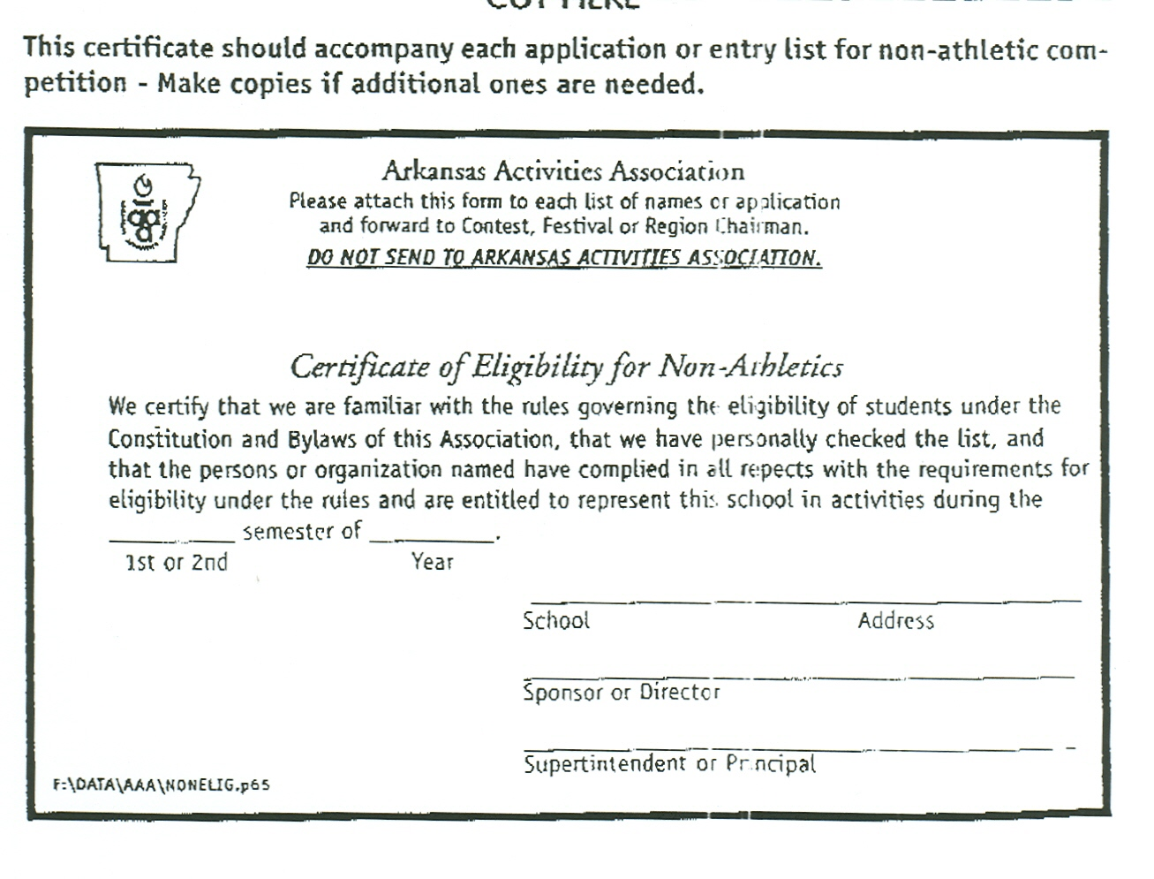
AAA/AGQBA Certification
School Name _________________________________
Eligible players who may play in Quiz Bowl tournaments this year.
Use a second form or back of form if needed for names
Name | Grade

Coach: ________________________ Date _________________

