Pendy I: Length and Period

Theory
In this investigation we will explore the relationship between the Length of a pendulum (independent variable) and the time it takes to make one complete swing – the Period (dependent variable). We will determine the Period of a pendulum of several lengths and then determine a function that models this data. The Period of a pendulum should be constant for any given length.

Equipment
TI Graphing calculator
CBR
RANGER program, or the CBL/CBR APP
Link Cable
About 3 meters of fishing line
Fishing sinker
Swivel hook

Setup
Connect the sinker to the swivel hook and tie the fishing line. Locate a support for the pendulum and position the CBR at least 0.5 meters from the closest approach of the pendulum bob.



Data Collection
Check to see that you have at least 12 000 bytes free on your calculator, or that you already have RANGER on your calculator if you have a TI-83, or TI-82. When you have enough space, load the RANGER program or use the CBL/CBR APP.

Run the RANGER program
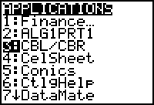

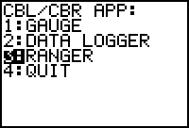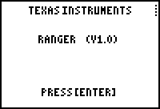

Select the SETUP/SAMPLE as shown below. You may need to adjust the time to get enough periods of the pendulum as you change the lengths.

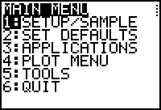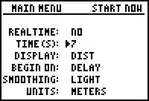

Get the Period of the pendulum for 7 different lengths. Pick lengths that represent the range from 0.5 meters to 3 meters as best you can. Measure the pendulum length from the connecting support to the center of mass of the sinker.

Swing the pendulum, with a small angle of displacement. When you get a nice graph, leave the RANGER program.

Determine the Period of the pendulum by finding how long it takes to go one full cycle. Subtract the x-values (time) from the CBR graph as shown below. Record these times (Periods) in the table below for each length as A, B, and C. Then average these times and place them in the Period column.
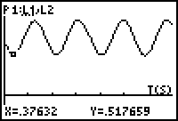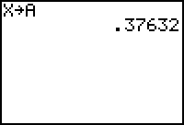

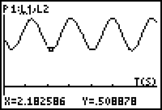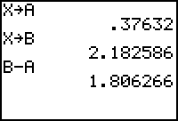

In this case the Period is 1.806 seconds, which could be Period A.

Length (m) | Period (sec) | Period A | Period B | Period C

Analysis
- Make a Scatter Plot of the Period as a function of Length.
- What Functional Model do you see in the plot?
- Give a Best Fit model for this function.
- What are the units of x, y, and the slope?
- Create a Scatter Plot of the Period² as a function of Length.
- What pattern do you see?
- Give a Functional model for this plot.
- What are the units of x, y, and the slope?
- Create a Scatter Plot of the Period as a function of the Length².
- What pattern do you see?
- Give a Functional model for this plot.
- What are the units of x, y, and the slope?
- Get the “True” Functional Model for the relationship between Period and Length of a pendulum. Compare your answer to question 3 to this Truth.
- Determine the value of g from your Best Fit Model.
- Use your model from question 3, and the Truth to complete the table below.
Length (m) | Period from your Model | Period from the Truth
1
7
11
0.1
0.01
100

- Determine the percent error for each measure in question 15.
- How well does your model match up now?

