Fall 2000 Final Examination
Answer each question completely and demonstrate the parts of your solution.

- Report all of your grades for this Quarter (see: the Grade Viewer at http://gradebook.fayar.net/PIV/piv.exe ) and then calculate your grade in this class if you made the following Portfolio scores on the Portfolio you are to turn in on the 21st.
 | 2nd Q
Overarching Process | 2
7 Systemic Parts of SwS Algebra 2 | 3
Your Ability to Test | 3
Working with Technology | 1
Growth | 2
Web Page/Free Choice | 3
Journal | 4
- How would you move in front of the CBR to make the following graph of Time vs. Distance?
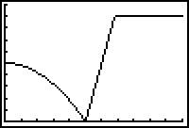
- Bubble Baby vs. Speed Racer - Going for the Tie:
If the following information is for Bubble Baby with Time in minutes and Dist in meters and Speed Racer can run the 100 meter dash in 0.33 minutes, where would Speed Racer need to stand if they both start the race at the same time, and we want a Tie for reaching the 100 meter mark. Give your equations, graph, and window.
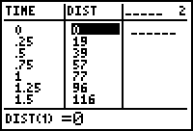
- Using the following data, produce a Histogram and give the Big 7. Then state one conjecture you can make based on the graph and the statistics.
School District | Expenses per kid
Bentonville | $ 4 304
Decatur | $ 4 681
Gentry | $ 4 258
Gravette | $ 4 332
Pea Ridge | $ 4 637
Rogers | $ 4 417
Siloam Springs | $ 4 534
Fayetteville | $ 5 262
Springdale | $ 4 554
Farmington | $ 4 134
Prairie Grove | $ 4 050
Elkins | $ 4 395
Lincoln | $ 4 736
West Fork | $ 4 577
Winslow | $ 4 790
Greenland | $ 4 221

- Sketch the graph resulting from the motion created by running away from the CBR into a door.
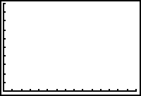
- Collect a set of data (at least 10 data pairs) that you feel represents a linear model. Find these data points by: a) designing and carrying out your own experiment, or b) using a data website (see http://fayar.net/east/teacher.web/Math/young/ ). Make a scatter plot of the data. Draw a line of best fit, and identify the equation of the line. Use your equation to make predictions with in and beyond the original data (use units). Assess, in the written word with quantification how well your linear model fits your data.
- Compare the results from the following situation, and determine how long, and when (day, date, and time) it will take under each plan to obtain $7 777. On January 1, 2001 you place your nana's gift of $477 in a Simple Interest Plan at 11%. After this calculation, use the Finance option on your calculator to determine the number of days it would take you to get the $ 7 777 if you had a rate of 8% interest, compounded daily.

- Use the Quadratic Formulas and one of the three methods to solve
.

